# Certain Trends in Uncertainty and Sensitivity Analysis: An overview of techniques and tools

Alternatives:

* Analyzing Uncertainty and Sensitivity: An overview of available software

Dominique Douglas-Smith1,2, Takuya Iwanaga2, Barry F. W. Croke1,2, Anthony J. Jakeman2

1Mathematical Sciences Institute, Australian National University, Canberra, Australia  
2The Integrated Catchment Assessment and Management Centre, Fenner School of Environment and Society, The Australian National University, Canberra, Australia

**Abstract:**

* Computers allow us to develop and run complex models but it is important to understand the complexities and determine when it is warranted
* UA/SA aid in assessing the complexities, if it is warranted, and under what conditions
* Software tools that embody these techniques and approaches have been developed and are continually being developed
* This paper applies a bibliometric approach to analyzing the trends of UA/SA approaches and relevant software packages
* We find ...

# Introduction

Computational modelling is a relatively young field which was constrained in its early years by the disproportionately high cost and limited availability of computational power. Since then computers have become ubiquitous, with vast amounts of available computational power and speed. Perhaps most importantly from a financial perspective, computational cost has now become cheaper than that of highly trained researchers. This has led computational modelling to become a key activity in many areas of research, whilst enabling an ever-increasing level of complexity to be modelled.

Here the level of complexity is reflected by the number of parameter factors a model takes as inputs. Parameter factors may also be referred to as ‘parameters’, ‘factors’ or simply ‘inputs’ in the literature (Norton, 2015). Increasing the number of parameters allows for a more detailed representation of the system being investigated, whilst also increasing computational cost and model complexity, often at an exponential rate. This is referred to as the curse of dimensionality, where each parameter represents a dimension. Increased detail (and thus complexity) may not always be justified or necessary with respect to the aims of the modeling exercise. Such complex models are described as being ‘over-parameterized’ (van Griensven et al., 2006).

Uncertainty and Sensitivity Analysis (UA/SA) helps modelers identify the relative importance of each parameter factor which influences model results within a given problem context. Each parameter factor may influence one or more outputs and could (conditionally) affect the importance of other factors; referred to as parameter interaction. Factors may be ‘insensitive’ – having little to no effect on model results – and can then be fixed (made static and unchanging) or removed to reduce complexity. Understanding the relative importance of factors that are ‘sensitive’ can aid in the development of better monitoring strategies and experiment design by, as an example, indicating the priority of data to be collected and how much is necessary. Limiting complexity helps to constrain the parameter space, which has many benefits. It can aid in reducing model runtime by eliminating the need to consider insensitive parameters, which then helps ease the computational cost of optimizing the model, and is a key activity in developing surrogate models.

The influence of uncertain parameters and how this impacts decision-making can be surveyed through Exploratory Modelling and Analysis (EMA). EMA could be described as the exploration of conditions represented through scenarios and conditions. These scenarios consider parameter and structural uncertainties in order to generate predictions under future conditions. SA, sampling techniques (such as Monte Carlo and factorial methods), and optimization techniques can be used in conjunction with EMA to great effect, especially when only partial information about a system is available (Kwakkel and Pruyt, 2013).

UA/SA may also be used as part of a quality assurance step. When applied in such a manner UA/SA can indicate, through statistical measures, questionable outputs due to data quality issues or bugs in the modelling software. Unexpected outputs may also be a result of parameter interactions and combinations that may not be possible. It is not suggested here that UA/SA is a complete substitute for code/model testing – rather it is a complement that further reinforces the validity of the model.

The importance of understanding how the model represents the problem frame is often underappreciated for a variety of reasons. Consequently, UA/SA processes may not be applied to an appropriate degree (Jakeman et al., 2006; Norton, 2015; Saltelli and Annoni, 2010)**.** Modelers may attempt to optimize and calibrate models without the requisite knowledge and understanding of the model behavior. Donald Knuth, a well-known computer scientist, once stated that premature optimization is the root of all evil (Knuth, 1974). This was in reference to software developers who often spend a lot of time and energy on modifying code to achieve better computational performance, sometimes without a clear understanding of the implications. The literature suggests that this is equally true in the context of modelling – one should not optimize a model without an adequate understanding of the role parameter factors play. UA/SA processes can help in this regard.

A significant volume of work has been conducted in the field of UA/SA. An initial query on the Web of Science database resulted in over 500,000 publications across all fields – far too many to comprehensively review, at least in a timely manner. In this paper we aim to provide 1) a brief introduction to the field of sensitivity analysis, especially for those new to the field of environmental modelling and analysis, 2) an overview of UA/SA research trends within the field of environmental modeling, and 3) a guide to the available software tools and packages. These goals are achieved through a hybrid bibliometric approach.

# The (hybrid) bibliometric approach

The collection of publications (the ‘corpora’) were gathered from Clarivate Analytics’ Web of Science (WoS) database using the WoS web-based Application Programming Interface (API). Use of the API enabled access to the publication data and metadata including titles, abstract text, author supplied keywords, and DOIs. The overarching subject areas and keywords included in the search parameters are specified in Table 1. Publications in the resulting corpora were taken to represent the field of uncertainty and sensitivity analysis in the overarching field of environmental modeling. The general search and analysis approach is depicted in Figure 1.

The collection of publications was iteratively and incrementally refined through a semi-autonomous process. Topic modelling was applied to cluster the publications based on semantic similarity, which aided in identifying relevant texts. Analysis of the trends and citations within relevant topics and their representative texts was conducted to construct an overview of the general research trend and identify software tools and packages. Additional complementary publications were selected based on the author’s own judgement to further the discussion. Further discussion of the approach is given in the following sub-sections.

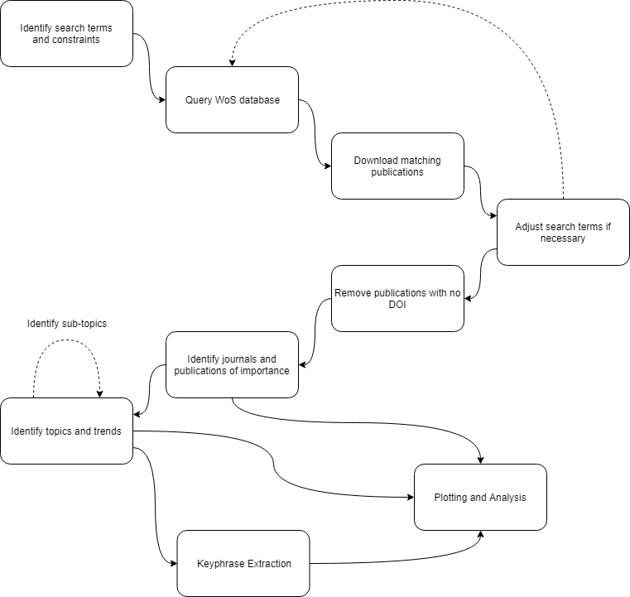

Figure 1. The hybrid bibliometric analysis process. Identification and subsequent analysis of the final corpora followed an iterative process through which irrelevant publications were progressively filtered.

## Initial search

The initial corpora for the analysis was identified by specifying the search phrase **[TS=("sensitivity analysis" OR "uncertainty analysis" OR "uncertainty quantification" OR "uncertainty propagation" OR "local sensitivity analysis" OR "LSA" OR "one-at-a-time" OR "exploratory modeling" OR "OAT" OR "global sensitivity analysis" OR "GSA" OR "all-at-a-time" OR "AAT") AND WC=("ENVIRONMENTAL SCIENCES" OR "WATER RESOURCES" OR "ENGINEERING ENVIRONMENTAL" OR "INTERDISCIPLINARY APPLICATIONS")]**. Only English language publications were considered for this study. Further details of the search phrase and the specific keywords used are given in Table 1 and Table 2. A time frame limit of 2000 to 2017 was put in place as the initial search resulted in **[over 500,000]** matches. Because scientific research is largely additive in nature (i.e. we build on prior works) and there is an exponential growth of published material (Bornmann and Mutz, 2015; Haddaway and Westgate, 2018), we assume in this analysis that most, if not all, relevant information is represented by the publications in the corpora. Data was retrieved with the use of Wosis, a python package developed in-house to simplify the process of querying the WoS database and aid in data analysis and visualization (**[ref package DOI]**).

Table 1. Keywords used in the overarching Web of Science query

|  |  |
| --- | --- |
| **Subject Area and Keywords** | **Comment** |
| Environmental Sciences |  |
| Water Resources |  |
| Engineering Environmental |  |
| Interdisciplinary Applications |  |

Table 2. Initial keywords used in search parameters

|  |  |
| --- | --- |
| **Keyword** | **Comments** |
| Sensitivity analysis |  |
| Uncertainty Analysis |  |
| Uncertainty Quantification |  |
| Uncertainty Propagation |  |
| Local Sensitivity Analysis (LSA) |  |
| One-at-a-Time (OAT) |  |
| Global Sensitivity Analysis (GSA) |  |
| All-at-a-time (AAT) | Not sure if correct term or widely used term. Term proposed by (Pianosi et al., 2016). |
| *Robust Decision Making* | *Application of UA/SA processes to identify “robust decisions” in management and decision making (e.g. choosing a path that is resilient to shocks and risks)* |
| *Parameter Space/Variability Space* |  |
| *Search Space* |  |

The initial corpora from WoS consisted of **[13 692]** publications from which documents without a valid DOI (**429 publications**) were removed. Further to this, publications which included “Proceedings” in the journal name were removed, and those corresponding to the keywords “life cycle assessment,” “product life cycle,” and “image processing.” Unrelated journals were excluded, and journals with less than three publications in the corpora. The final corpora consisted of **[11718]** publications.

The publications in the field have been increasing at an exponential rate (depicted in Figure 2) with Journal of Hydrology having the most publications overall and experiencing the largest year-on-year gain within the analyzed time frame. The 10 most cited papers from across the top 5 journals (by number of publications) were then identified and collated (see Table 3). Most were published in either the Journal of Hydrology (four in total) or Environmental Modelling and Software (five publications), with the single exception published in Structural and Multidisciplinary Optimization.

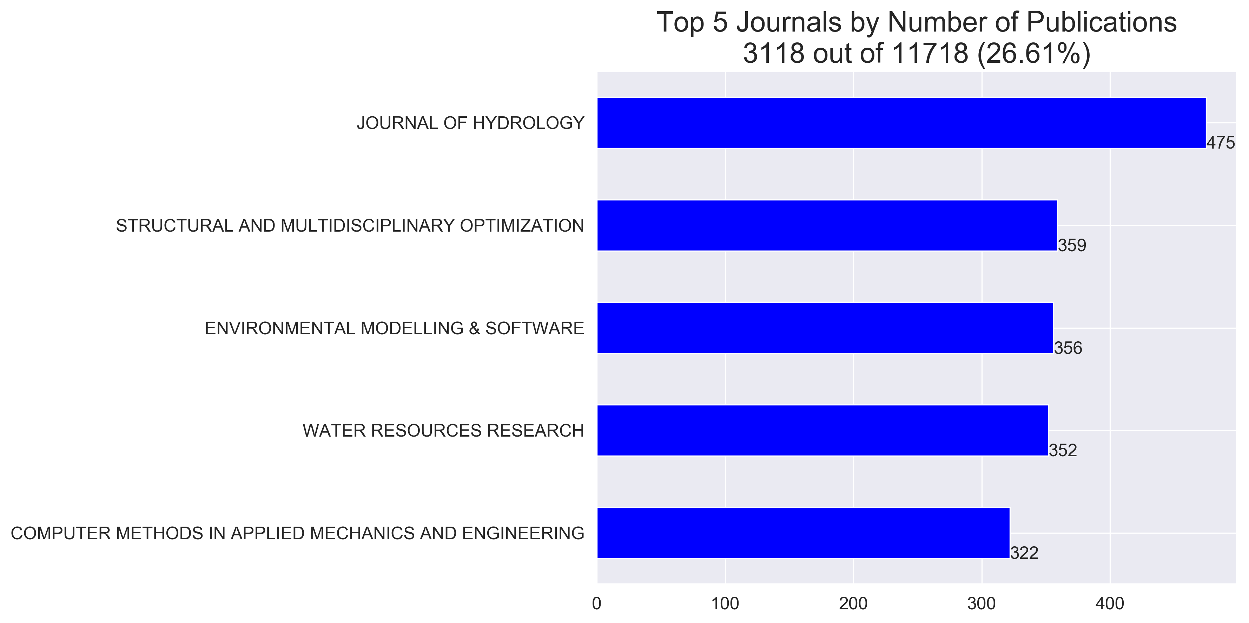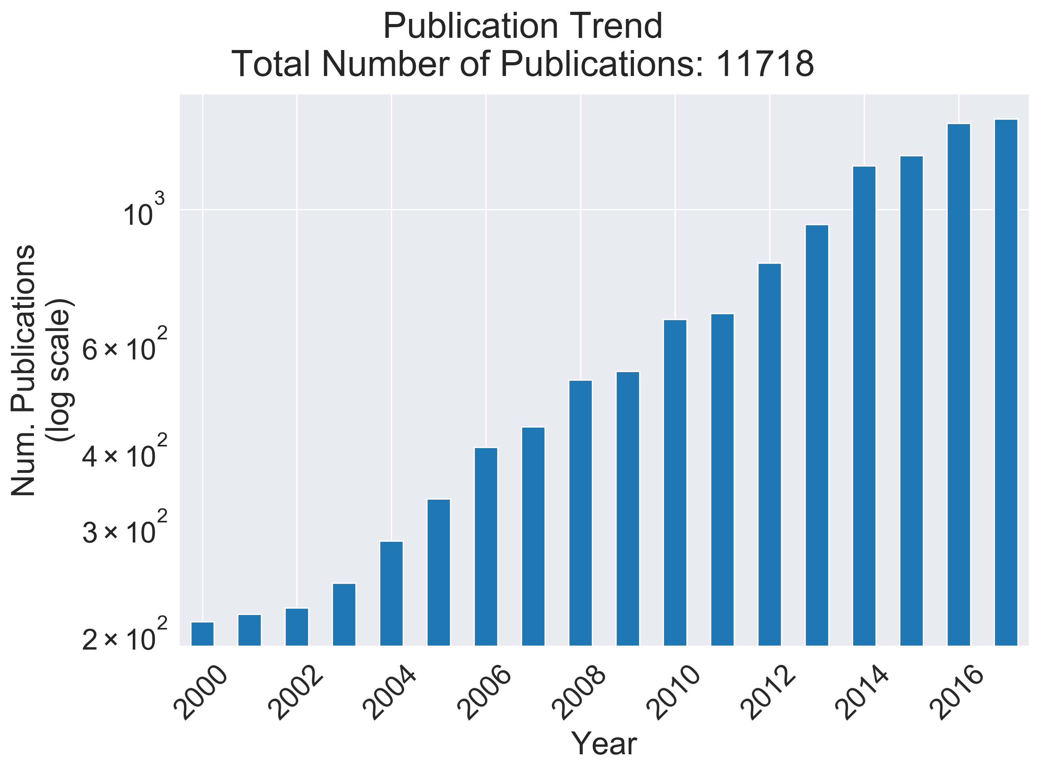

Figure 2. Publication trends over 2000 to 2017. Journal of Hydrology contributed the most publications in the time frame (483, see left panel). Publications within the corpora have been occurring at an exponential rate (see right panel).

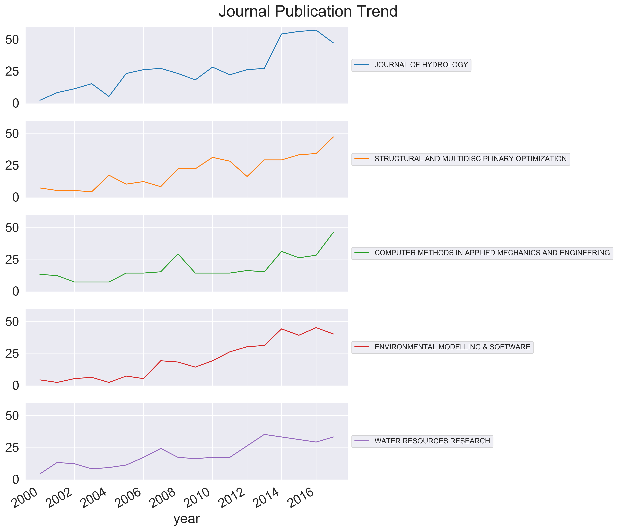

Figure 3. Publication trend by journal across the time frame. All journals in the top 5 (by number of publications) saw an increase in publications related to the keywords used.

Table 3. The top 10 cited papers in the top 5 journals (by number of publications).   
With the exception of a single paper, all were published in the Journal of Hydrology, and Environmental Modelling and Software

|  |  |  |  |  |  |
| --- | --- | --- | --- | --- | --- |
| **Authors** | **Year** | **Title** | **Journal** | **Citations** | **DOI link** |
| Bennett, ND|Croke, BFW|Guariso, G|Guillaume, JHA|Hamilton, SH|Jakeman, AJ|Marsili-Libelli, S|Newham, LTH|Norton, JP|Perrin, C|Pierce, SA|Robson, B|Seppelt, R|Voinov, AA|Fath, BD|Andreassian, V | 2013 | Characterising performance of environmental models | ENVIRONMENTAL MODELLING & SOFTWARE | 581 | https://dx.doi.org/10.1016/j.envsoft.2012.09.011 |
| Campolongo, F|Cariboni, J|Saltelli, A | 2007 | An effective screening design for sensitivity analysis of large models | ENVIRONMENTAL MODELLING & SOFTWARE | 578 | https://dx.doi.org/10.1016/j.envsoft.2006.10.004 |
| Abbaspour, KC|Yang, J|Maximov, I|Siber, R|Bogner, K|Mieleitner, J|Zobrist, J|Srinivasan, R | 2007 | Modelling hydrology and water quality in the pre-alpine/alpine Thur watershed using SWAT | JOURNAL OF HYDROLOGY | 560 | https://dx.doi.org/10.1016/j.jhydrol.2006.09.014 |
| van Griensven, A|Meixner, T|Grunwald, S|Bishop, T|Diluzio, A|Srinivasan, R | 2006 | A global sensitivity analysis tool for the parameters of multi-variable catchment models | JOURNAL OF HYDROLOGY | 555 | https://dx.doi.org/10.1016/j.jhydrol.2005.09.008 |
| Refsgaard, JC|van der Sluijs, JP|Hojberg, AL|Vanrolleghem, PA | 2007 | Uncertainty in the environmental modelling process - A framework and guidance | ENVIRONMENTAL MODELLING & SOFTWARE | 510 | https://dx.doi.org/10.1016/j.envsoft.2007.02.004 |
| Merritt, WS|Letcher, RA|Jakeman, AJ | 2003 | A review of erosion and sediment transport models | ENVIRONMENTAL MODELLING & SOFTWARE | 407 | https://dx.doi.org/10.1016/S1364-8152(03)00078-1 |
| Sigmund, O|Maute, K | 2013 | Topology optimization approaches A comparative review | STRUCTURAL AND MULTIDISCIPLINARY OPTIMIZATION | 382 | https://dx.doi.org/10.1007/s00158-013-0978-6 |
| Saltelli, A|Annoni, P | 2010 | How to avoid a perfunctory sensitivity analysis | ENVIRONMENTAL MODELLING & SOFTWARE | 355 | https://dx.doi.org/10.1016/j.envsoft.2010.04.012 |
| Oudin, L|Hervieu, F|Michel, C|Perrin, C|Andreassian, V|Anctil, F|Loumagne, C | 2005 | Which potential evapotranspiration input for a lumped rainfall-runoff model? Part 2 - Towards a simple and efficient potential evapotranspiration model for rainfall-runoff modelling | JOURNAL OF HYDROLOGY | 321 | https://dx.doi.org/10.1016/j.jhydrol.2004.08.026 |
| Yang, J|Reichert, P|Abbaspour, KC|Xia, J|Yang, H | 2008 | Comparing uncertainty analysis techniques for a SWAT application to the Chaohe Basin in China | JOURNAL OF HYDROLOGY | 312 | https://dx.doi.org/10.1016/j.jhydrol.2008.05.012 |

|  |  |  |  |  |  |  |  |  |
| --- | --- | --- | --- | --- | --- | --- | --- | --- |
| **Journal** | **No. papers in corpora** | **Percentage of corpora** | **Starting year (ending year)** | **No. papers/active years** | **No. software packages papers** | **Percentage of software packages papers** | **Starting year (ending year) in software packages collection** | **No. papers/active years in software packages collection** |
| Journal of Hydrology | **475** | **0.04** | 2000 (2017) | **28** | 6 | 0.03 | 2009 (2017) | 1 |
| Structural and Multidisciplinary Optimization | 359 | 0.03 | 2000 (2017) | 21 | 11 | 0.05 | **2000 (2016)** | 1 |
| Environmental Modelling & Software | 356 | 0.03 | 2000 (2017) | 21 | **23** | **0.11** | 2004 (2017) | **2** |
| Water Resources Research | 352 | 0.03 | 2000 (2017) | 21 | 3 | 0.01 | 2009 (2017) | 0.4 |
| Computer Methods in Applied Mechanics and Engineering | 322 | 0.03 | 2000 (2017) | 19 | 4 | 0.02 | **2001 (2017)** | 0.3 |
| Journal of Computational Physics | 278 | 0.02 | 2001 (2017) | 17 | 2 | 0.01 | 2015 (2017) | 1 |
| Hydrological Processes | 268 | 0.02 | 2000 (2017) | 16 | 2 | 0.01 | 2000 (2013) | 0.2 |
| Science of the Total Environment | 263 | 0.02 | 2000 (2017) | 15 | 5 | 0.02 | 2009 (2015) | 1 |
| Atmospheric Environment | 241 | 0.02 | 2000 (2017) | 14 | 1 | 0.004 | 2003 (2003) | 1 |
| Environmental Science & Technology | 204 | 0.02 | 2000 (2017) | 12 | 1 | 0.004 | 2016 (2016) | 1 |
| International Journal for Numerical Methods in Engineering | 201 | 0.02 | 2000 (2017) | 12 | 4 | 0.02 | 2003 (2015) | 0.3 |

## Topic Identification

Topic models attempt to cluster the corpora into similar or related topics. They group texts by the words occurring commonly in each text, relying on the assumption of common semantics in various fields. Topic models can be more efficient at discovering texts relevant to a field compared to an exhaustive manual search as it identifies relevant texts based on commonly occurring words which indicate a specific context or topic. For example, sensitivity in the context of sensitivity analysis would be expected to appear in texts containing words such as “analysis”, “uncertainty”, and “modelling”, whereas it could also appear in relation to perceptiveness of technologies to stimulus, in which case it would appear with such words as “precision,” “technology,” “response.” Through this approach a semi-supervised search can be conducted wherein the topic model is applied, irrelevant topics filtered, and the process repeated until only the relevant texts are left.

Topic modeling can be of great benefit to scientific literature reviews. (Achakulvisut et al., 2016) outline the shortcomings of a standard keyword search for scientific literature: including a likelihood of bias, scientific specialization, and the rapid emergence of new fields. It is becoming increasingly difficult for researchers to communicate and apply the available knowledge, given the sheer volume of papers and corresponding hours needed for manual sorting (Westgate et al., 2018). Topic modelling, in taking advantage of machine learning, can greatly reduce the required hours for a thorough, less-biased, and more systematic review of a subject area. A key advantage, for example, is that it can analyze the data stored in abstracts, a richer source of information than keywords.

In this study Non-negative Matrix Factorization (NMF) was applied to model the topics within the corpora. NMF is a linear-algebraic algorithm which requires the number of topics to be pre-specified by the modeler. A publication may be assigned to one or more topics with the NMF approach. The NMF model requires a document-term matrix, also referred to as a bag-of-words matrix, in which each row represents a document, and each column vector represents a considered word token. A complete explanation of the NMF approach is not in the scope of this paper, however further information can be found in the following references (Arora et al., 2012).

For our purposes the word tokens consisted of the text found in the title, abstract, and keywords. Term Frequency-Inverse Document Frequency ranking (TF-IDF) was used to select 1000 tokens from these texts. A high TF-IDF score indicates that the word has a high frequency within specific document(s), but a low number of occurrences within the entire corpora. Weighting the score in such a manner has the effect of filtering out commonly used tokens which may not have high semantic importance (such as “the”, “and”, etc). TF-IDF is a common ranking method used in text mining (Beel et al., 2016).

Topic modeling and bibliometric analysis have been applied before to reduce the time and difficulties encountered when conducting systematic reviews (Westgate and Lindenmayer, 2017). Although software is available to aid in these bibliometric approaches, currently no single software package provides all necessary functionality. Arguably the application of conjunctive systematic mapping and bibliometric analysis is still in its infancy (as evidenced by Nakagawa et al., 2018).

### Citation Analysis

Citation analysis indicates the papers being referred to by other papers within the corpora as well as the overall number of citations the given publication has received, the assumption here being that impactful papers are more likely to be cited. The number of citations is then used to indicate papers that are of high importance to the subject at hand.

### Trend Analysis

Analyzing the trend of publications within topic areas can aid in identifying the general focus and direction taken by the research community.

### Key Phrase Identification

The corpora can be further constrained through key phrase identification, which the wosis package can apply. The automated process identifies and displays a pre-selected number of key phrases for each given publication aiding reviewers to identify irrelevant publications. The approach implemented in wosis attempts to identify phrases of interest by scoring sentences based on its similarity with other sentences throughout the abstract text.

Sentences with three or less tokens (i.e. words, numbers, or other; counted by splitting the text on individual spaces) are ignored. Sentence similarity is scored based on the ratio of the intersection of two sentences. This functionality is provided by the Python `fuzzywuzzy` string matching package through the `token_set_ratio()` function. Candidate sentences are initially filtered based on the presence of a root word – taken to be the token that appears in the middle of a candidate phrase; an approach used in Rabby et al. (2018).

This approach assumes that important features of the publication (such as its findings) will be introduced or framed and subsequently discussed in the abstract text. The implemented approach is therefore dependent on the abstract length, with longer texts preferred and poor performance can be expected for very short abstracts (e.g. no key phrases could be identified for abstracts less than three sentences long). Comparisons with RAKE – Rapid Automatic Keyword Extraction (Rose et al. 2010) – implemented through the rake-nltk python package indicates that the above approach produces, subjectively, key phrases that are more relevant for the purpose of this study.

[**TODO**: Table or figure comparing the results from RAKE algorithm vs the custom approach implemented in wosis]

# Key terminologies and methods

The most naïve method of SA is one-at-a-time (OAT). OAT SA involves perturbing one model factor, and examining the resulting output, whilst fixing all other factors.

OAT is a local approach to SA. Other local SA methods examine the partial derivatives of output with respect to each input parameter. These are computed at one point in the sample space to determine sensitivity indices. The simplicity of the procedure is advantageous, as well as being computationally inexpensive for first order derivatives. However, LSA methods only provides a robust SA for linear or additive models (Saltelli and Annoni, 2010): it doesn’t account for parameter interactions and becomes computationally expensive when higher order effects are considered.

More generally, a global sensitivity analysis (GSA) examines the variation in output resulting from variation across all the inputs.

GSA methods can be classed into two broad categories – derivative- and variance-based. Derivative-based GSA methods provide indices which characterise the distributional properties of partial derivatives (Razavi et al., 2019). Partial derivatives are computed for a selection of sample points (as opposed to one base point) and are combined.

Variance-based approaches determine how different factors contribute to model variance by analysing and decomposing the variance in model outputs (Razavi et al., 2019).

The strength of GSA methods comes in that they provide a more robust depiction of model uncertainty, in particular by comprehensively accounting for parameter interactions.

A weakness is computational cost and an assumption of random distribution of output values in the parameter space.

A third category of variogram-based methods was proposed by (Razavi et al., 2019). These methods characterise sensitivity by generating directional variograms associated with each parameter. The methods account for the spatial distribution of the model response. Variogram-based methods determine which parameters have the most controlling influence on the model output, and hence the model uncertainty.

When implementing a GSA, sampling methods are required to adequately represent parameter space whilst limiting computational expense. OAT and LSA do not require sampling. For GSA, Monte Carlo (MC) sampling is commonly used, although it offers a limited representation of the total space. Latin Hypercube sampling (LHS) resolves this issue (Norton, 2015). A weakness of LHS is that the single sample it generates cannot be enlarged without altering the distributional properties: the user should be aware of the required sample size before implementing the method (Razavi et al., 2019). LHS is an example of a stratified sampling method, and these methods, as well as MC and Sobol’ sequences, are used for variance-based GSA. Other commonly used sampling techniques are those designed specifically for particular SA methods, such as FAST and the Morris method (Pianosi et al., 2016).

Table 4. Common UA/SA sampling and analysis techniques, their descriptions, and key texts

| **Name** | **Abbreviation** | **Description** | **More information** |
| --- | --- | --- | --- |
| Monte Carlo | MC | Generates random sample points from a probability distribution (Gan et al., 2014). | (Metropolis and Ulam, 1949) |
| Morris method | - | Ranks parameters by influence on output and non-linearity. Each parameter is stepped along trajectories; usually the number of trajectories is less than the number of parameters.  The starting points are random and uniformly distributed.  The parameters are perturbed once in succession along the trajectory, in random order.  The resulting sample consists of the changes in model output caused by each parameter’s perturbation (Norton, 2015). | (Morris, 1991) |
| Latin Hypercube sampling | LHS | The range of each parameter in the parameter space is partitioned into $N$ equal-probability divisions.  One sample is taken from each of the $N$ partitions, generating $N$ samples per parameter, and a sample from each set of $N$ samples is chosen for each parameter.  The process is repeated for the remaining samples until no samples remain (Norton, 2015). | (McKay et al., 1979) |
| Fourier Amplitude Sensitivity Test | FAST | The output is estimated by a sum of sinusoids at frequencies given by a fixed chosen integer and other multiples of the base frequency.  Each parameter becomes a function of sin, the base frequency, and a parameter $s$ ranging from $-π$ to $π$ (Norton, 2015). | (Cukier et al., 1973) |
| Derivative-based Global Sensitivity Measure | DGSM | Sensitivity indices are computed by taking the integral over the function domain of the square of the partial derivatives of each factor with respect to the function (Sobol’ and Kucherenko, 2009). | (Sobol’ and Kucherenko, 2009) |

# Typical sensitivity analysis process

SA methods determine where the uncertainty in a model is coming from (Saltelli and Annoni, 2010). Typically, the analysis identifies factors or groups of factors that have the greatest impact on model uncertainty. Regardless of the analysis being conducted, whether it be SA, UA, or EMA, the primary conceptual idea is that of mapping a selection of model inputs to their results (i.e. associate the inputs to their resultant outputs). **[explanation of ua/sa/em difference]**

(Pianosi et al., 2015) identify three stages in a sensitivity analysis: selecting a sample of input values from the variability space, running a model evaluation against these input values, and applying a sensitivity analysis method to the input/output samples to compute sensitivity indices.

Here, the *variability space* refers to all possible combinations of values that can be assigned to a model’s input parameter set. By running the model with the values sampled from the variability space and taking note of the resultant outputs, analyses can be conducted to calculate the influence that a specific input, or set of inputs, may have; their sensitivities. The sample of inputs, ideally, would be suitably inclusive as to capture the entire range of possible parameter values without excessive computational cost. Knowledge of the probability density function of the model parameters is also useful, to focus the analysis on the regions with the highest probability (Norton, 2015). Random sampling with a uniform probability density over the parameter range is commonly assumed, but this assumption lacks accuracy (see Norton, 2015).

Common sampling techniques include Monte Carlo sampling, Latin hypercube sampling, and the Morris screening method. After evaluating the model over the sampled inputs, a sensitivity analysis is conducted. A local sensitivity analysis identifies the importance of a factor’s influence on model output by examining the partial derivative of the output with respect to the factor. The term local refers to these derivatives being taken with respect to a single point in parameter space. Such a SA method will produce a robust inference for linear or additive models (Saltelli and Annoni, 2010).

# Overview of recent developments

Recent impactful publications in sensitivity analysis suggest a shift from a previous deference to local sensitivity methods. Prior to 2010, ‘one-factor-at-a-time’ (OAT) local SA was the most prevalent practice in the literature (Saltelli and Annoni, 2010). Our bibliometric analysis showed an increased interest in GSA methods, occurring after 2010 (**Fig.**). It seems modelers have come to realize the greater importance of higher quality sensitivity analyses, especially for improving the reliability of forecasting, prediction, and policy making. (Saltelli and Annoni, 2010) demonstrated the inefficacy of OAT analyses using a geometric proof, wherein it was shown that simply varying the parameter values one at a time cannot adequately capture the output space. They argued that such OAT analyses are, in all but the simplest (linear/additive) cases, unsuitable. Whilst it is not possible to ascertain the direct impact of this paper on current sensitivity analysis practices, it at least reflected the changing attitudes towards SA that were developing in the modelling community.

In the past decade, there has been an increasing awareness of the shortcomings of local SA, and more efficient, comprehensive UA/SA techniques and approaches have been sought. Developers search for the best compromise between global sensitivity measures and computational efficiency. There has been a recently increased interest in global SA based on design of experiments, as these methods are recognized as the currently best available compromise (Gan et al., 2014). Despite the increased interest in GSA evidenced by the bibliometric analysis, local SA and OAT methods are still in use. It is difficult to ascertain the extent of continued OAT analysis in the modelling community through keyword analysis, as most researchers applying this technique will not explicitly refer to it as OAT. A keyword-match was run over the corpora, using the keywords “local sensitivity”, “OAT”, “one-at-a-time”, and “perturb”. The resulting papers were **[751]** in number. As a percentage of the corpora, these papers are decreasing.

Having such a volume of publications returned by the search, a keyword-match was used to sort them into their respective fields. Fields searched for were hydrology, chemical engineering, mechanical engineering, ecology, risk assessment, technology, agriculture, computational physics, computer science, statistics, and mathematical modeling. The fields were chosen based on the top 20 journals by publication in the topic area. All fields, except hydrology, showed a decreasing trend as a percentage of the corpora. Hydrology had an increase of roughly 1% over the timeframe. The top five fields by publication were chemical engineering (146), hydrology (137), technology (121), ecology (102), and agriculture (78). One must bear in mind the limitations to such analysis, as some returned papers may have been those condemning OAT: the top cited paper from the top five journals by publication was (Saltelli and Annoni, 2010).

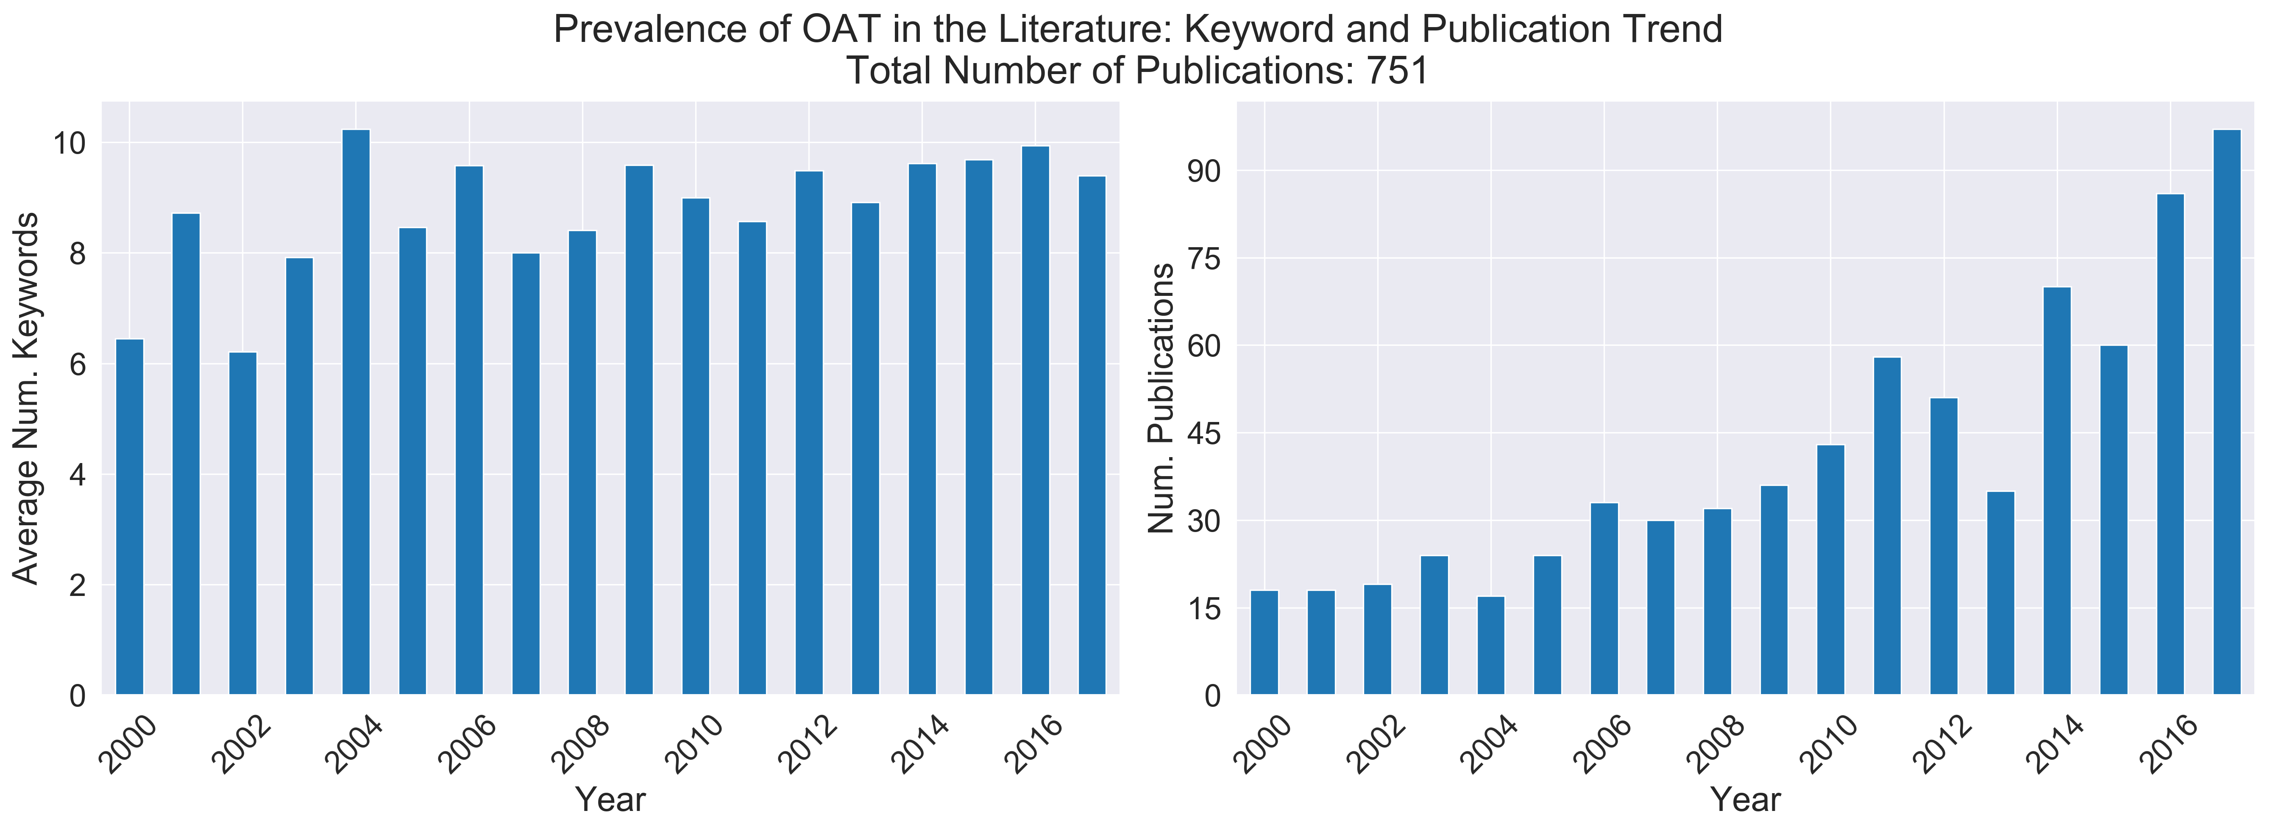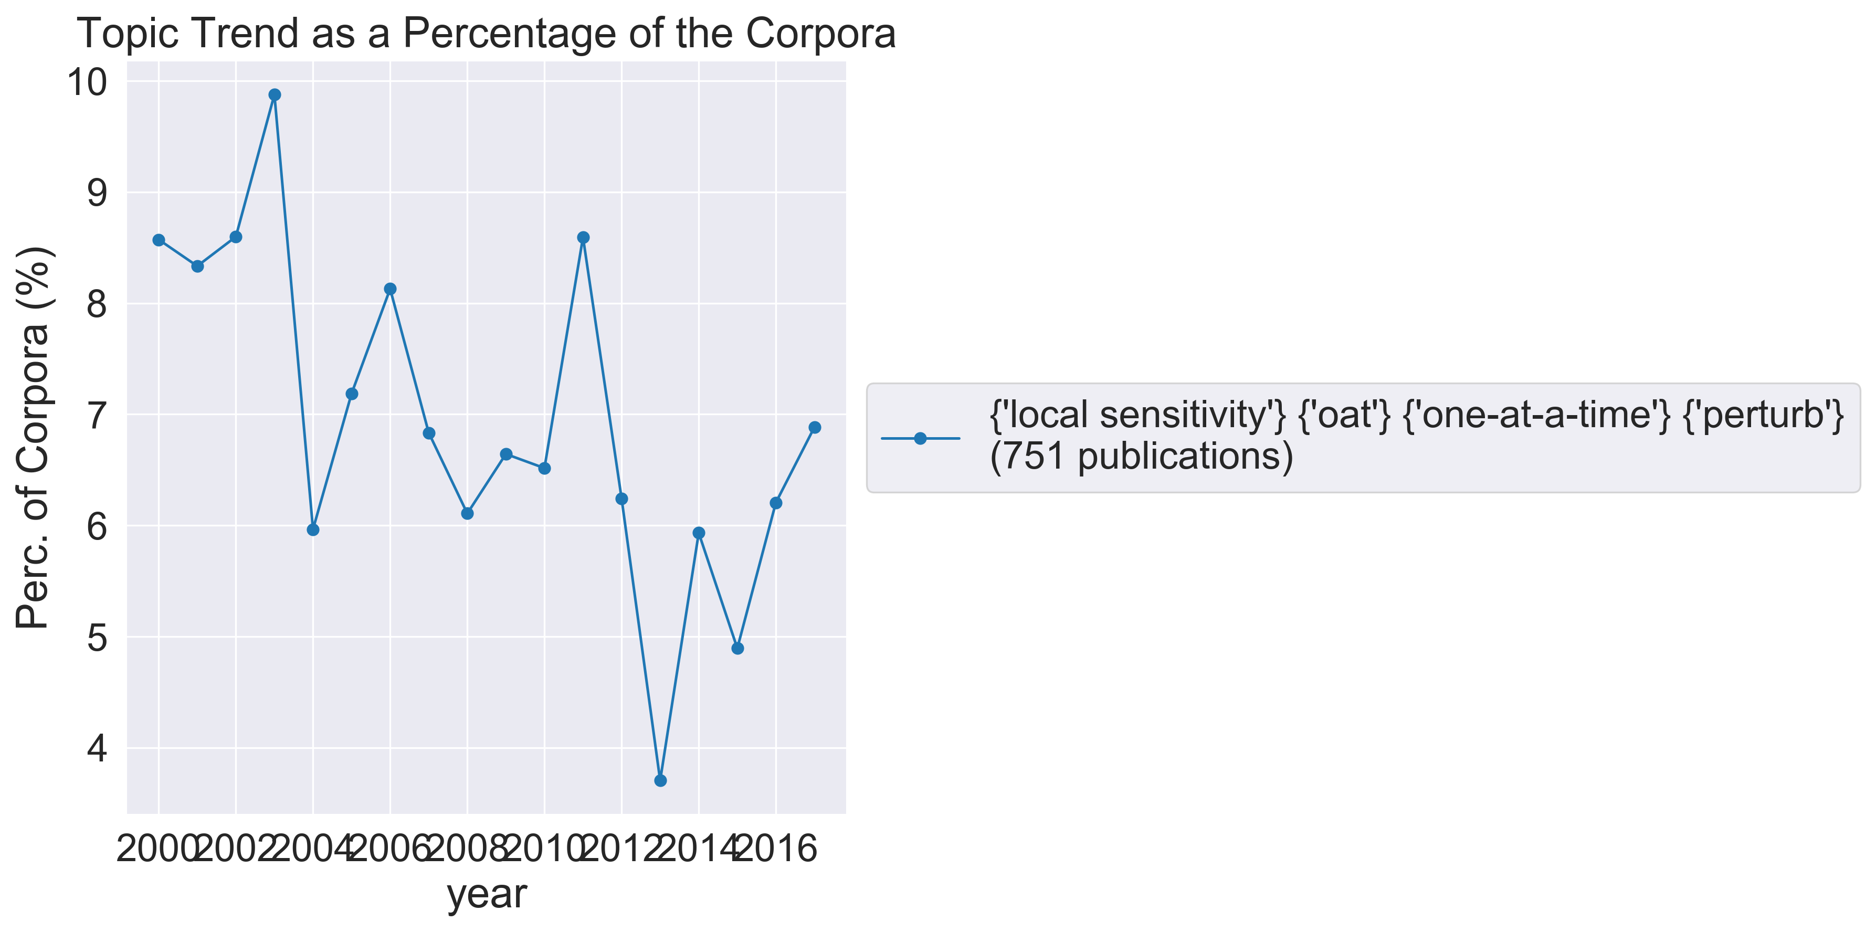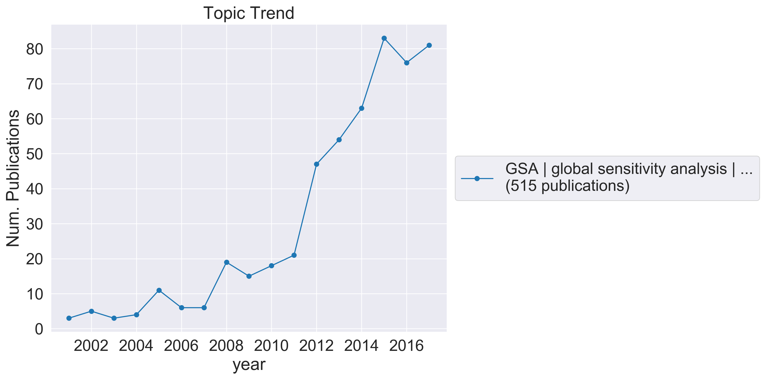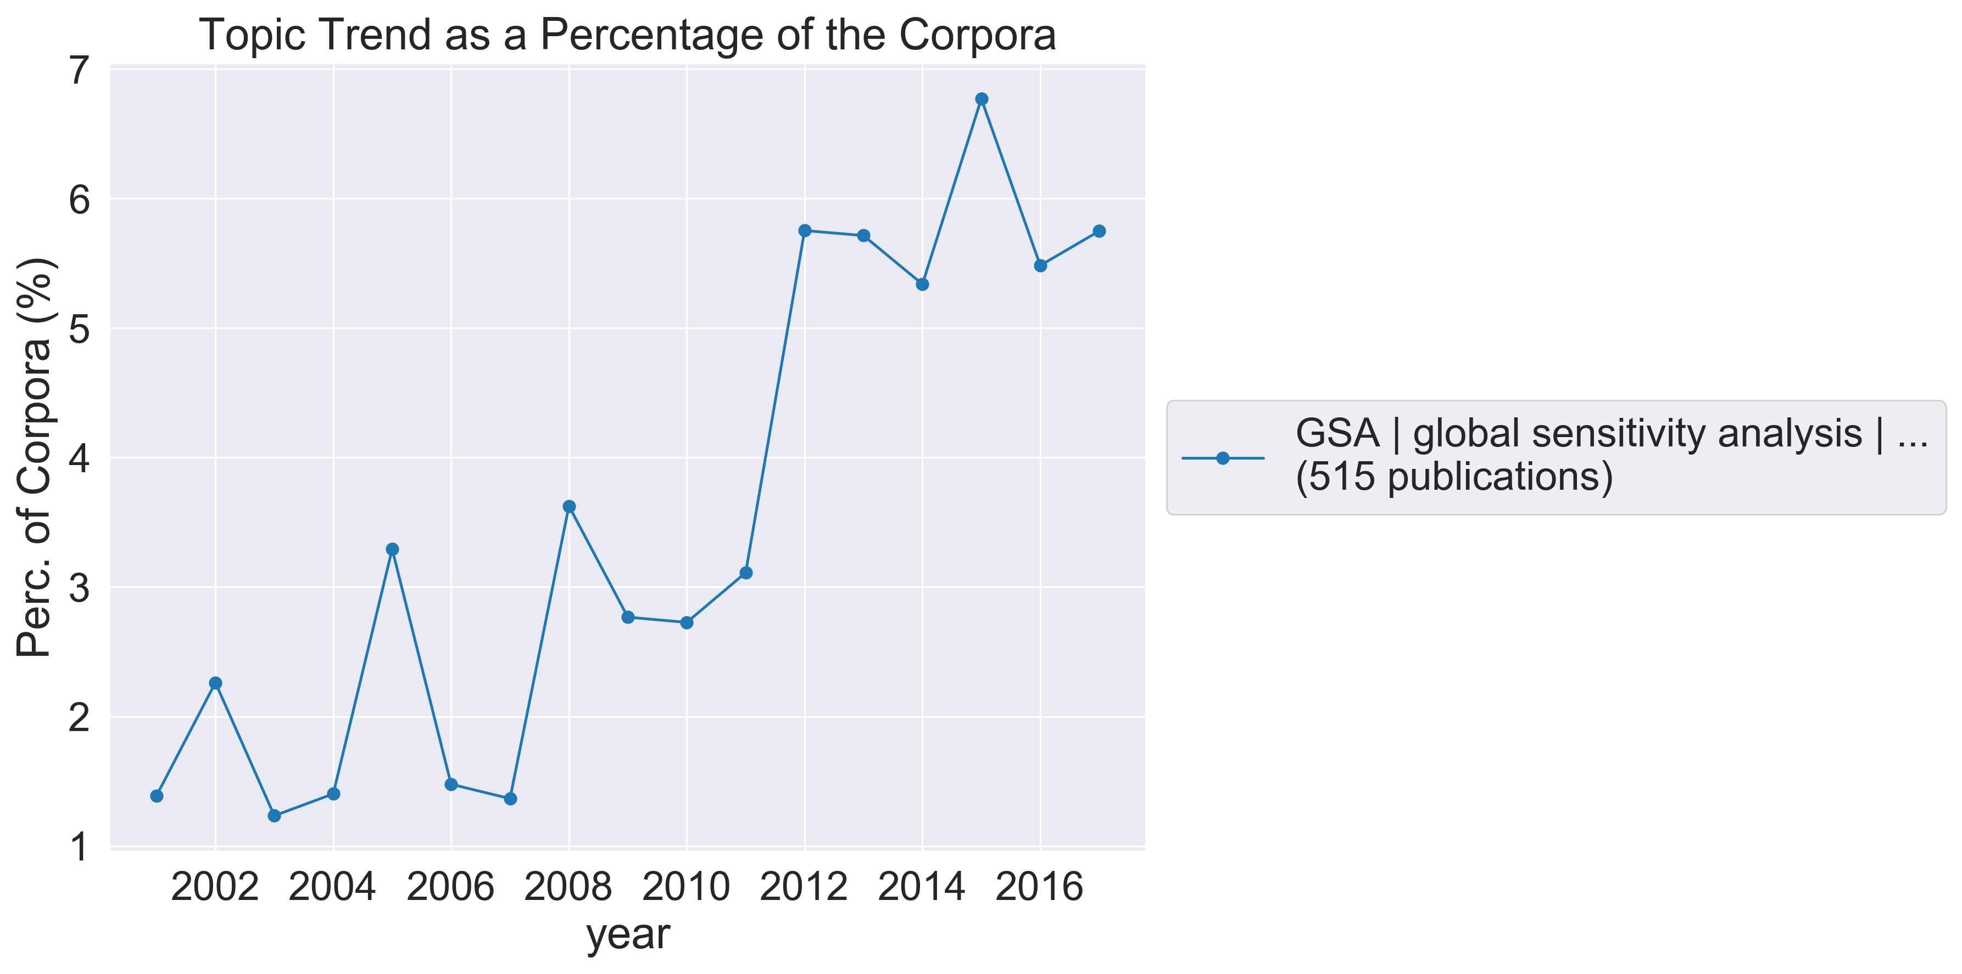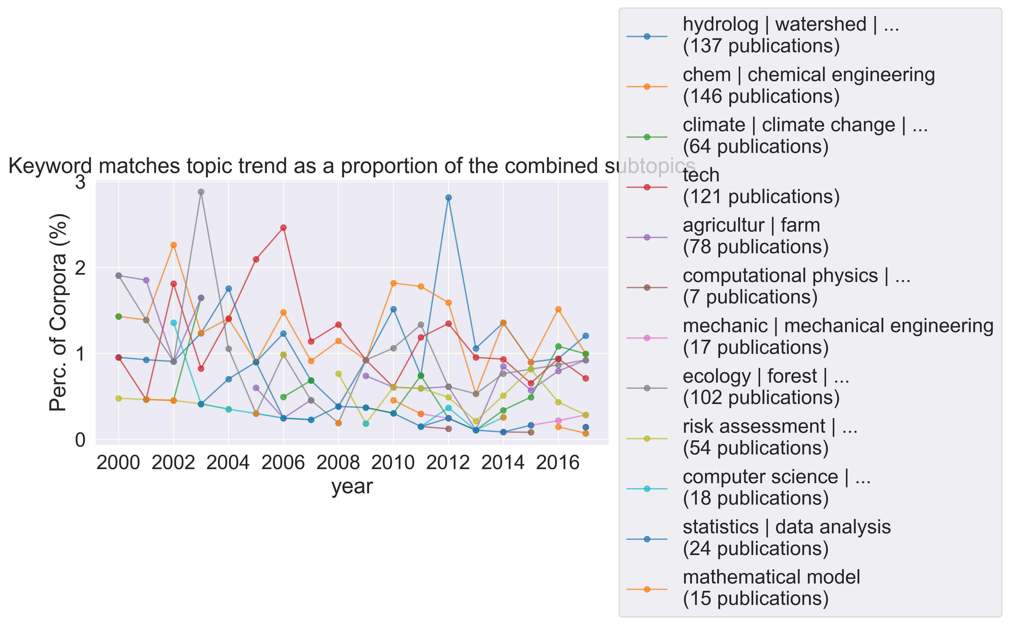

Sensitivity analysis (SA) packages released in the last ten years appear to be more concerned with best practices in modelling and software design. The purposes of these packages are more generalized, and the packages themselves offer a more comprehensive toolkit for uncertainty quantification (UQ). (Pianosi, et al, 2015) outline three principles of good practice for a sensitivity analysis package: the ability to apply multiple sensitivity analyses to one sample, provision of tools to assess and revise user choices, and visualization tools.

Similarly, and extending these points, (Marelli and Sudret, 2014) outlined the limitations of currently available SA packages: current packages lack generality, are too complex, lack extendibility and the ability to use high-performance computing, are intrusive (require tight-coupling to the model code, rather than working as a black – or gray - box), lack portability between operating systems, and lack collaborative development.

More comprehensive packages released in recent years also include test functions and case studies for research and educational purposes. Documentation is more detailed and includes examples and tutorials. The packages surveyed did not appear to provide information about sampling and SA methods and which ones are most appropriate to given models. This emphasizes the importance of an active user community to share knowledge and update code.

A keyword-matching search for best practices revealed increased interest in the years 2014-2016. Only 25 papers returned the search query. A key-phrase extraction algorithm facilitated identifying the fields publishing in this area. The largest number of publications concerned model validation and development (11, especially regarding environmental contexts: hydrology and chemistry), followed by environmental risk assessment (8, including emissions), SA (3), life cycle assessment (2, regarding sustainable production and consumption), and legislation (1, regarding climate change and ecology).

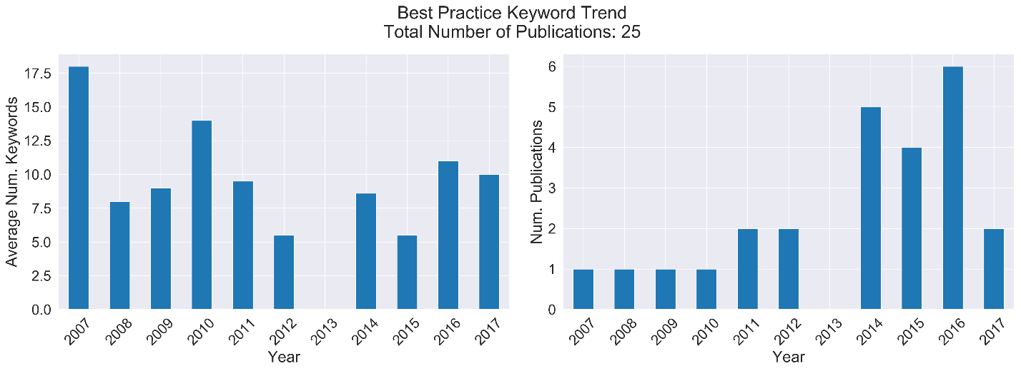

Furthermore, alternative methods for handling uncertainty have been developed, especially to handle scenarios in which there is large uncertainty, but in which accurate predictions are necessary for future policy making. In such cases, one proposed approach is EMA, which uses computational experiments to systematically explore the consequential outcomes of model uncertainty (Kwakkel and Pruyt, 2013). Rather than simply minimizing uncertainty, uncertainty is treated as inevitable, and responses can be planned to respond to the various feasible outcomes that the model could produce.

## Identified Topic(al) areas

Running a topic model on the corpora enabled us to refine the corpora to those publications most relevant to our analysis, the idea being that the topic model would be run until all the resulting topics were relevant.

A topic model was run on the corpora, obtaining five topic areas, two of which were of interest to this study. Topics 1 to 3 were considered relevant to SA, optimization, and UA, respectively. The topics had the keywords “model parameters sensitivity models data analysis parameter flow calibration time”, “optimization design method shape topology problem sensitivity element structural finite”, and “uncertainty stochastic quantification carlo monte bayesian method uncertainties random polynomial”, respectively. The three topics were combined and a further topic model was run on the combined collection. This produced five topics, of which Topic 1 appeared relevant to SA, Topic 2 to optimization, and Topics 3 and 4 to UA. The topics had the keywords “model sensitivity parameters analysis data flow models parameter soil results”, “optimization design shape topology method sensitivity structural problem analysis element”, “uncertainty bayesian uncertainties carlo monte model quantification models analysis data”, and “stochastic random method polynomial chaos quantification expansion equations collocation solution”, respectively.

Combining these topics and running a topic model produced five topics, again Topic 1 appeared relevant to SA, Topic 2 to optimization, and Topics 3 and 4 to UA. The keywords were now “model sensitivity parameters analysis data models parameter calibration based soil,” “optimization design shape topology method sensitivity structural problem analysis element,” “uncertainty bayesian uncertainties carlo monte quantification analysis models assessment probabilistic,” and “stochastic random polynomial method chaos quantification expansion equations problems collocation,” respectively. A further topic model was run on this combination of topics, but the resulting topics all seemed relevant to the aims of this paper.

Topic modelling the corpora helped to create a collection of papers more relevant to the study (UA/SA). The chosen number of topic models and topics seemed optimal for filtering the given corpora whilst not restricting too far.

The resulting topics were combined (the resulting collection will be referred to as “combined topics”), and a keyword-match was run to sort the publications into those relevant to UA, SA, and optimization. The resulting collections contained 1940, 2751, and 1360 publications, respectively.

A keyword-matching algorithm was applied to the combined topics, identifying those papers relevant to frameworks and guidelines for UA/SA, and those relevant to applications of UA/SA. The reason for doing so being that a previous topic model had revealed the existence of these two topic areas in the corpora. Two collections were produced, which will be referred to as “Frameworks” and “Applications,” respectively. After the first citation analysis of these papers, it was clear that there was significant overlap between the categories, and in particular, the papers that overlapped were more relevant to Frameworks than Applications. Hence, after the first keyword match, the papers matching to Frameworks were removed from the combined topics before performing a keyword-match for applications on the remaining papers in the collection.

## Research Trends and Directions

A trend analysis of the UA, SA, and optimization topics shows a yearly increase for all three topics, however SA and optimization saw a yearly decrease as a percentage of the combined topics.

The Applications and Frameworks collections both show yearly increases, however the Applications papers decrease proportional to the combined topics.

For Frameworks papers, the top five journals by publication all showed an increasing publication trend. These journals were Structural and Multidisciplinary Optimization, Journal of Computational Physics, Environmental Modelling & Software, and Journal of Hydrology.

For Application papers, the journal publication trend of the top five journals by number of publications shows an increase in publications for those papers coming from Computer Methods in Applied Mechanics and Engineering, Structural and Multidisciplinary Optimization, Journal of Computational Physics, and Journal of Hydrology. Publications from the International Journal for Numerical Methods in Engineering showed only a slight increase over the timeframe.

Further to this, the 10 most cited papers from across the top five journals for both topics were identified and collated. For Frameworks, the 10 most cited papers came from Environmental Modelling & Software (3), Structural and Multidisciplinary Optimization (3), Journal of Hydrology (2), Journal of Computational Physics (1), and Computer Methods in Applied Mechanics and Engineering (1). For Applications, the 10 most cited papers came from Journal of Hydrology (5), International Journal for Numerical Methods in Engineering Hydrological Processes (2), and Journal of Computational Physics (3).

A keyword-match was used to search for newer SA methods, active subspaces and variograms, in the corpora. Papers relating to active subspaces first appear in 2015, there are eight in total in the corpora. Variogram-related publications begin in 2001, however those specifically relating to the application of variograms to SA only appear from 2016. There are six publications in total relevant to variogram-based SA in the corpora.

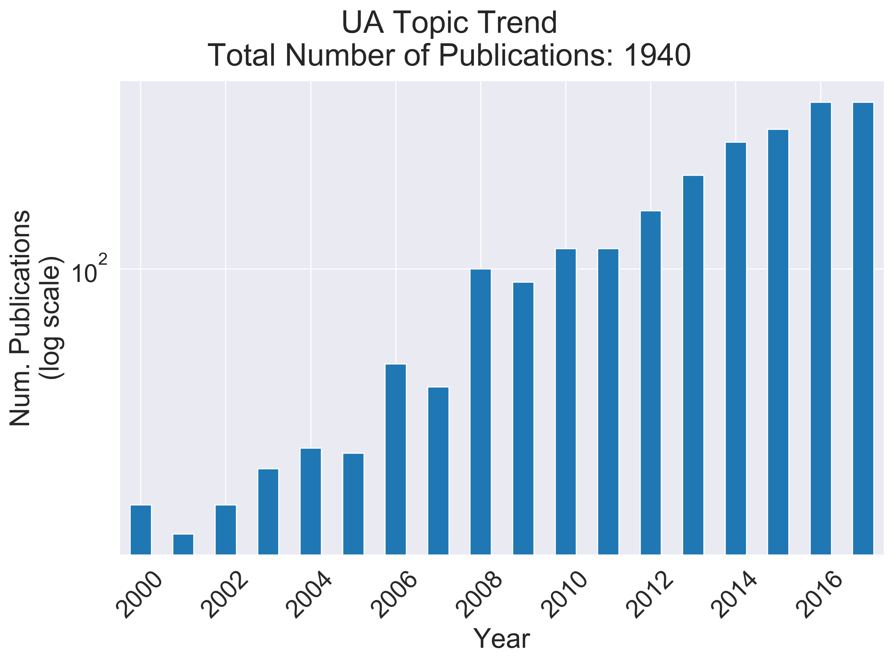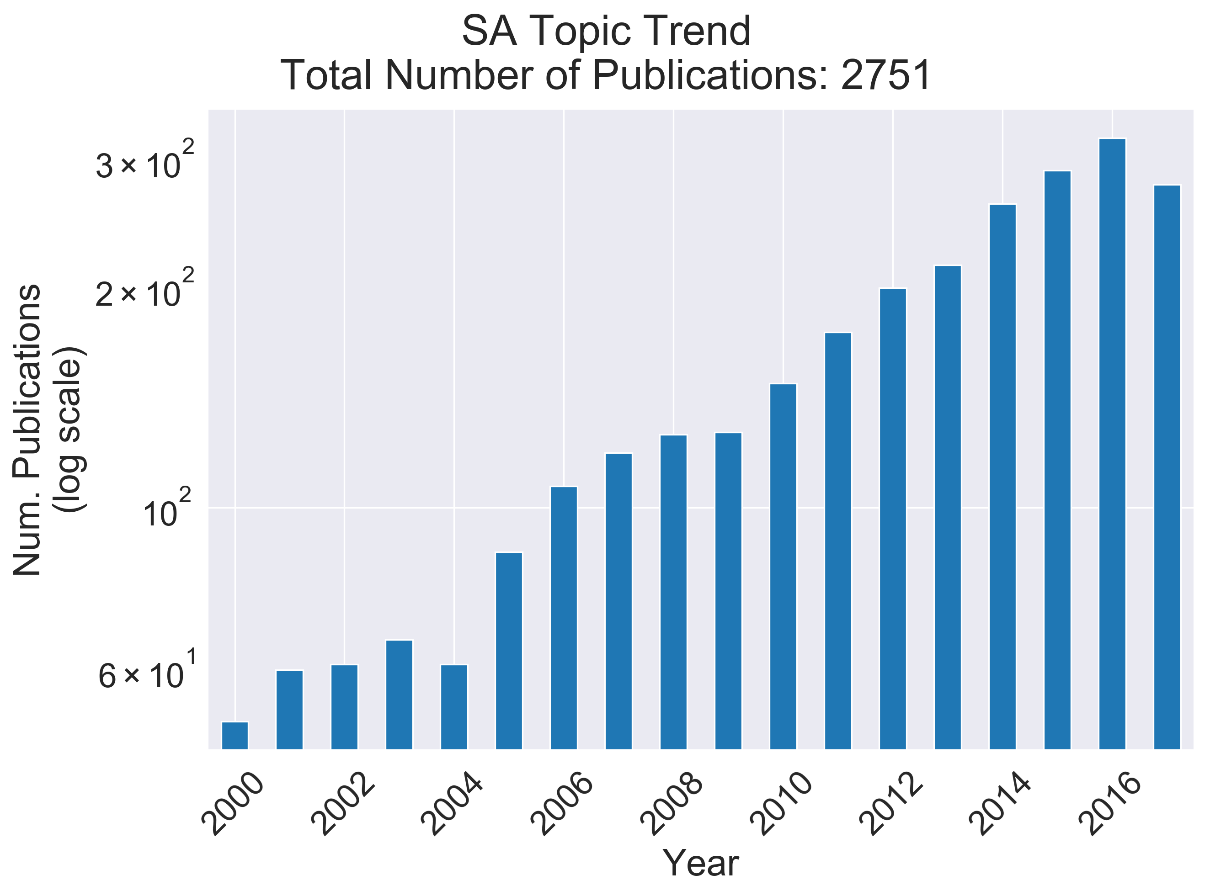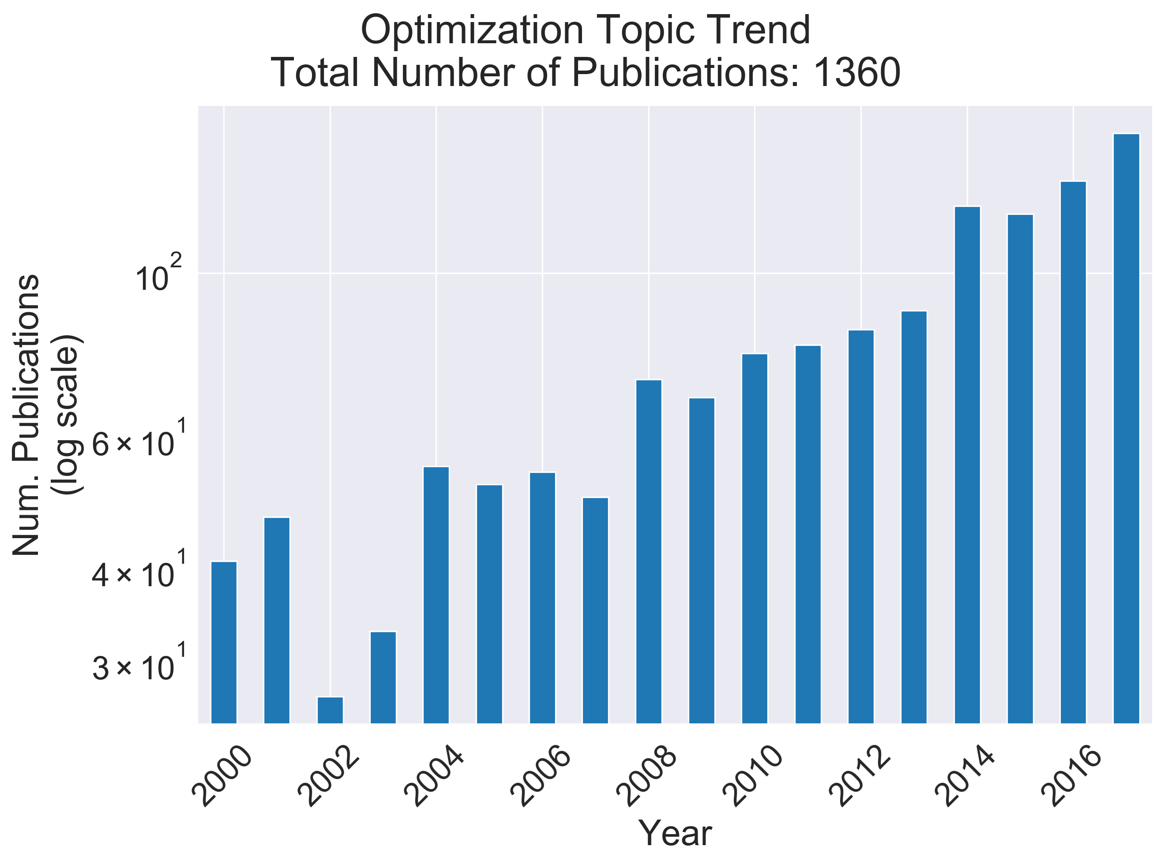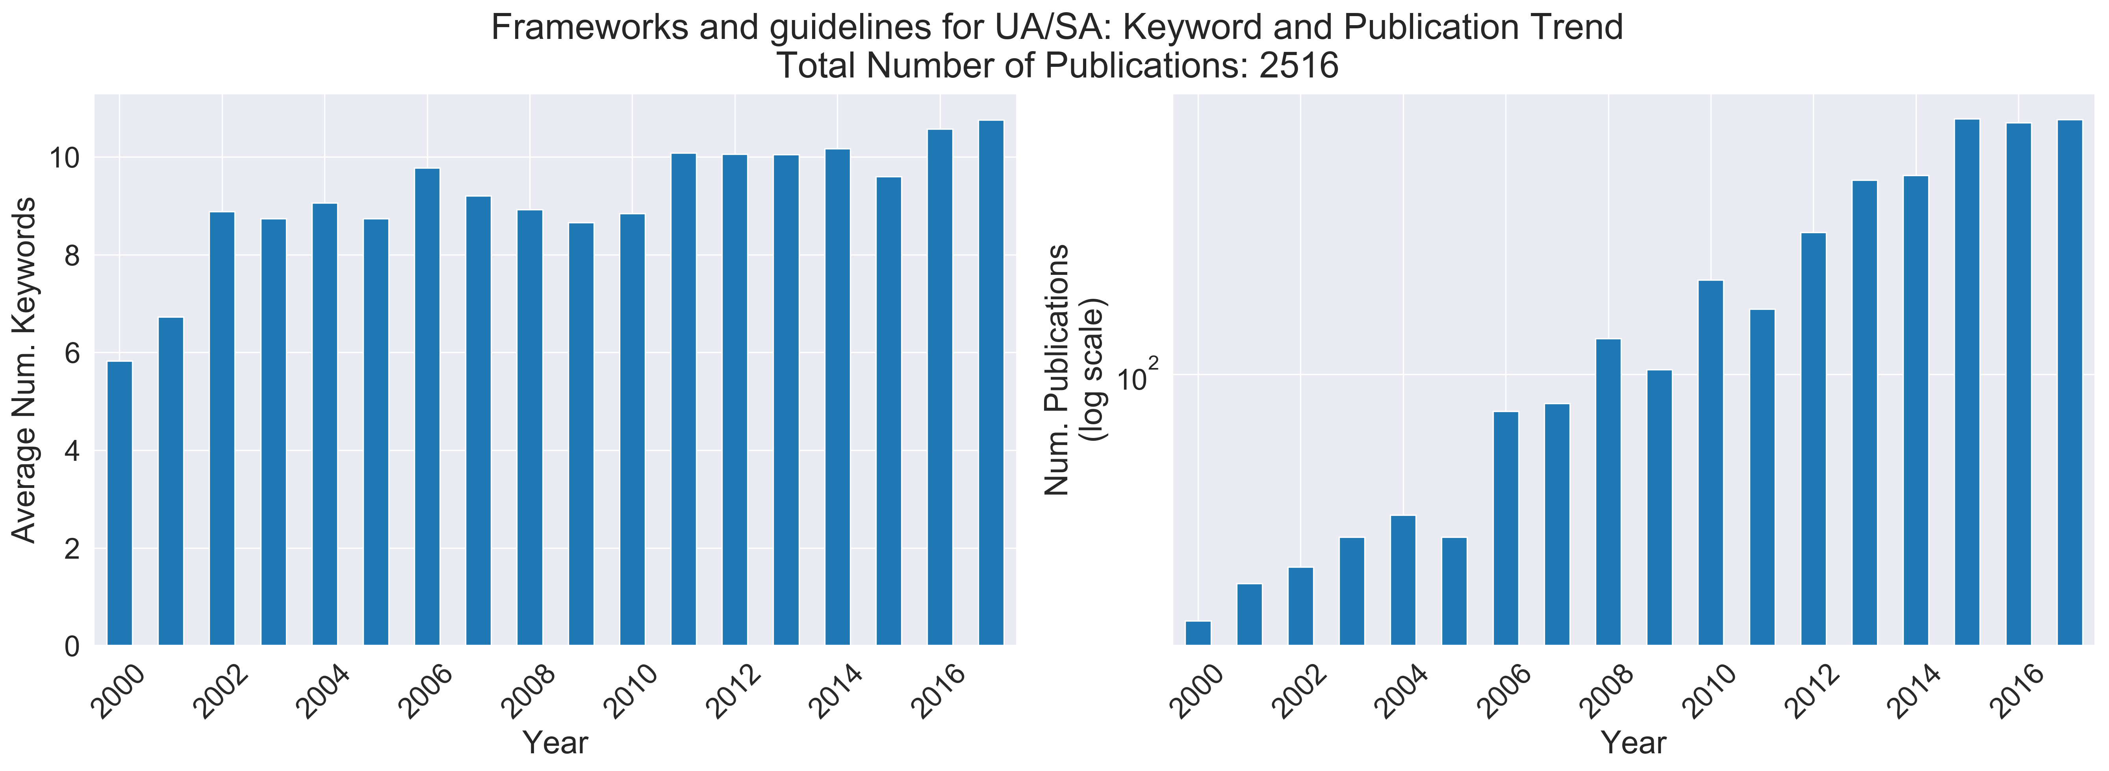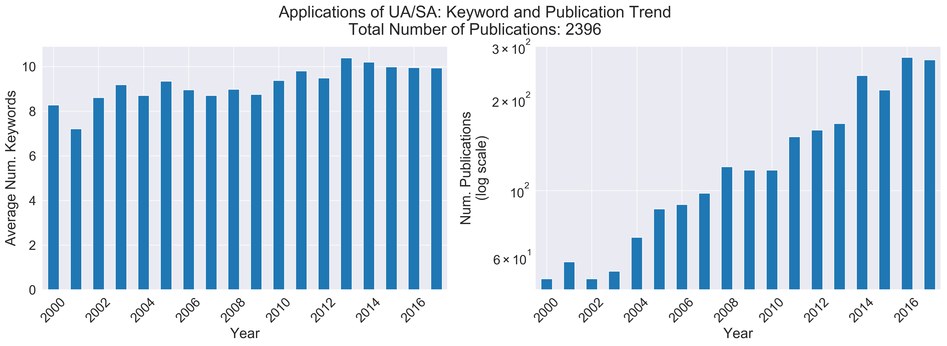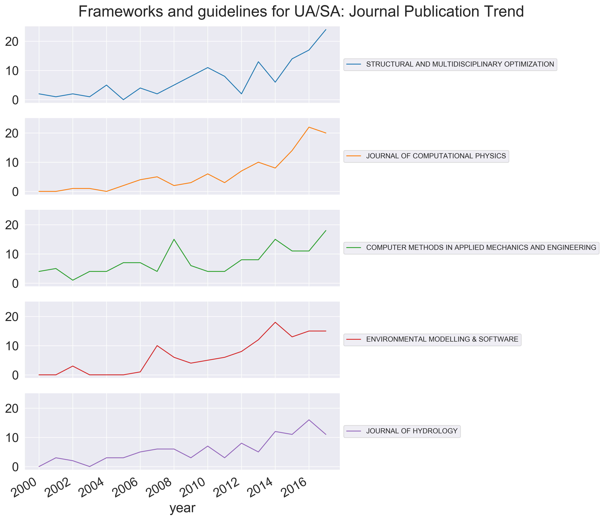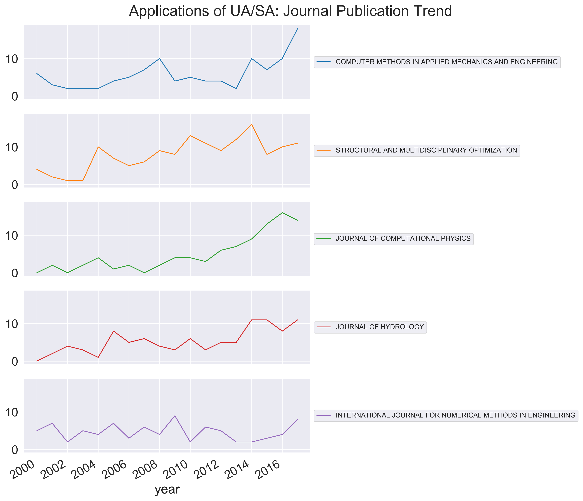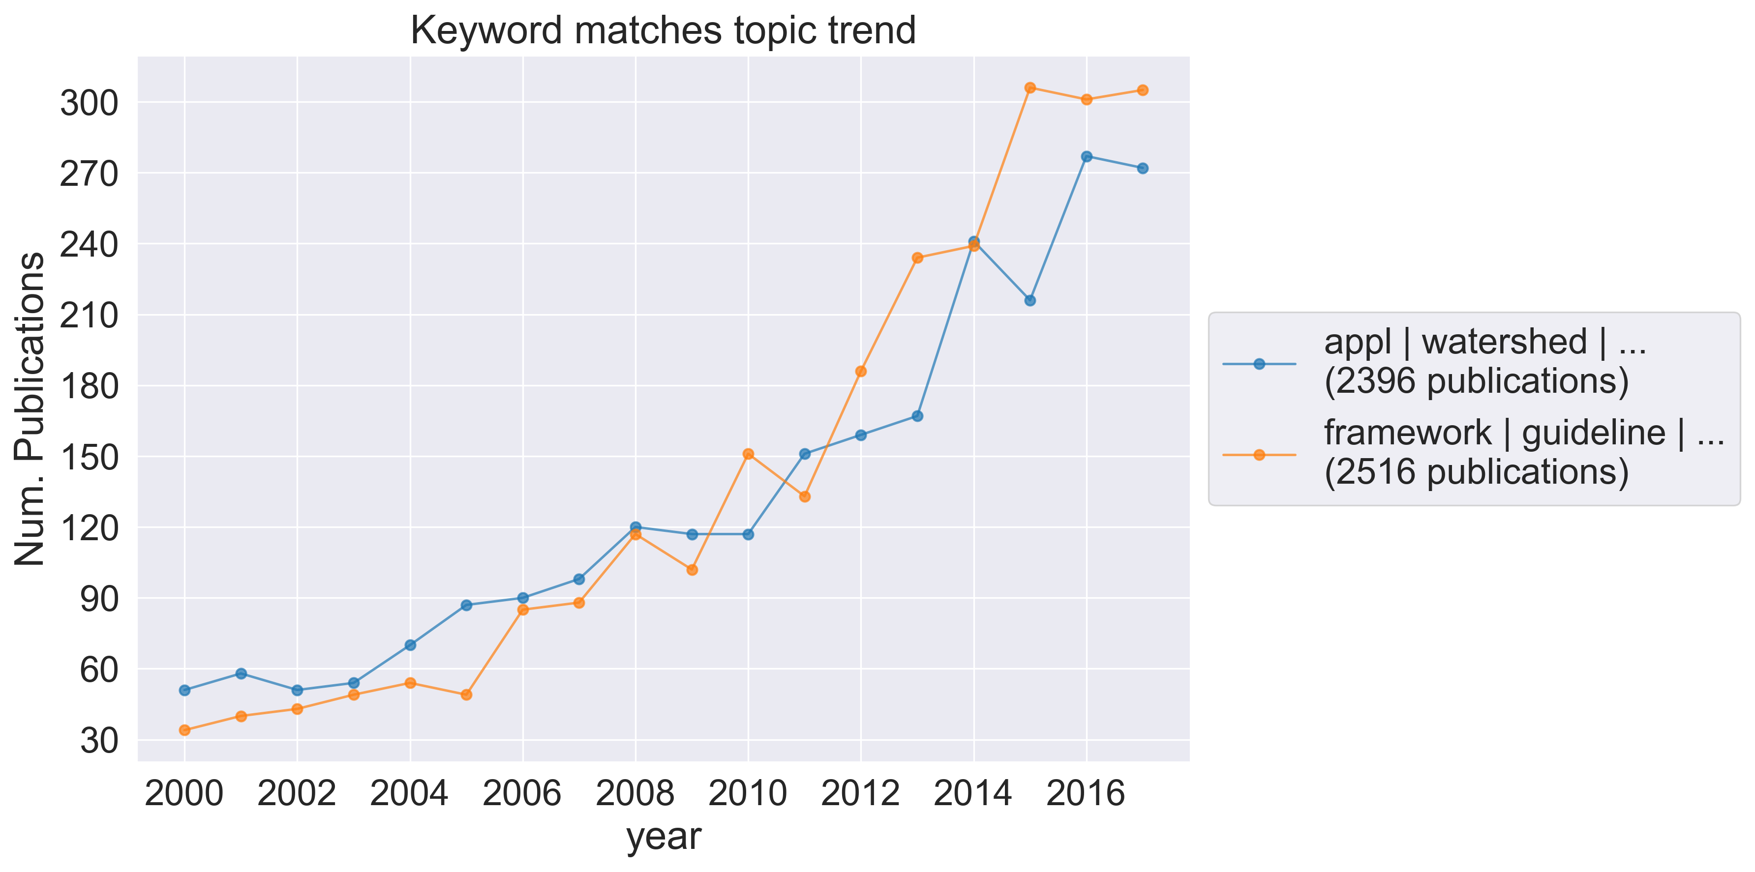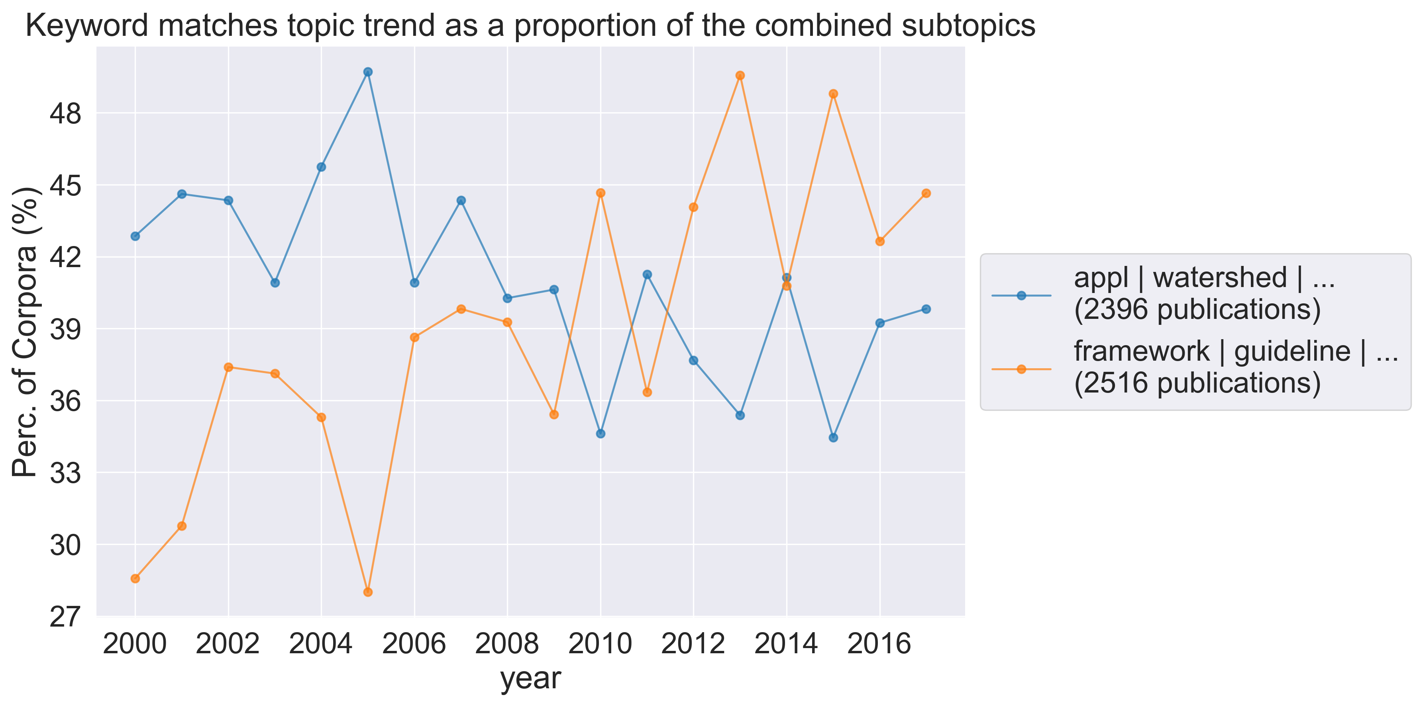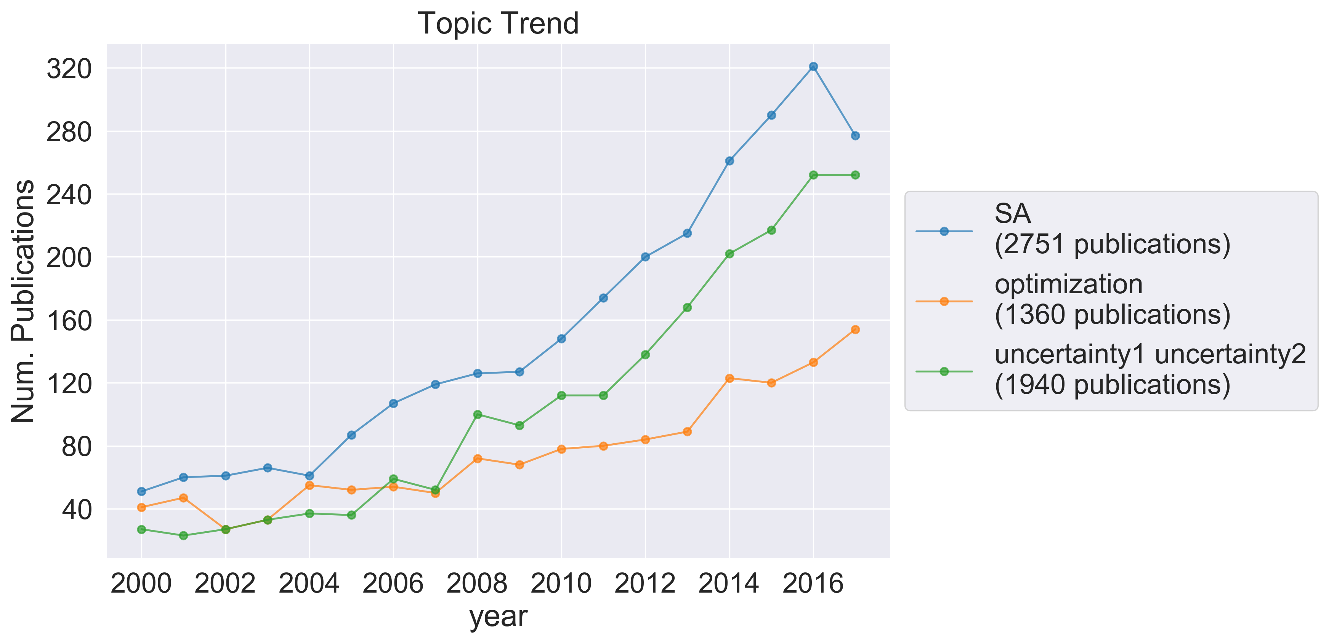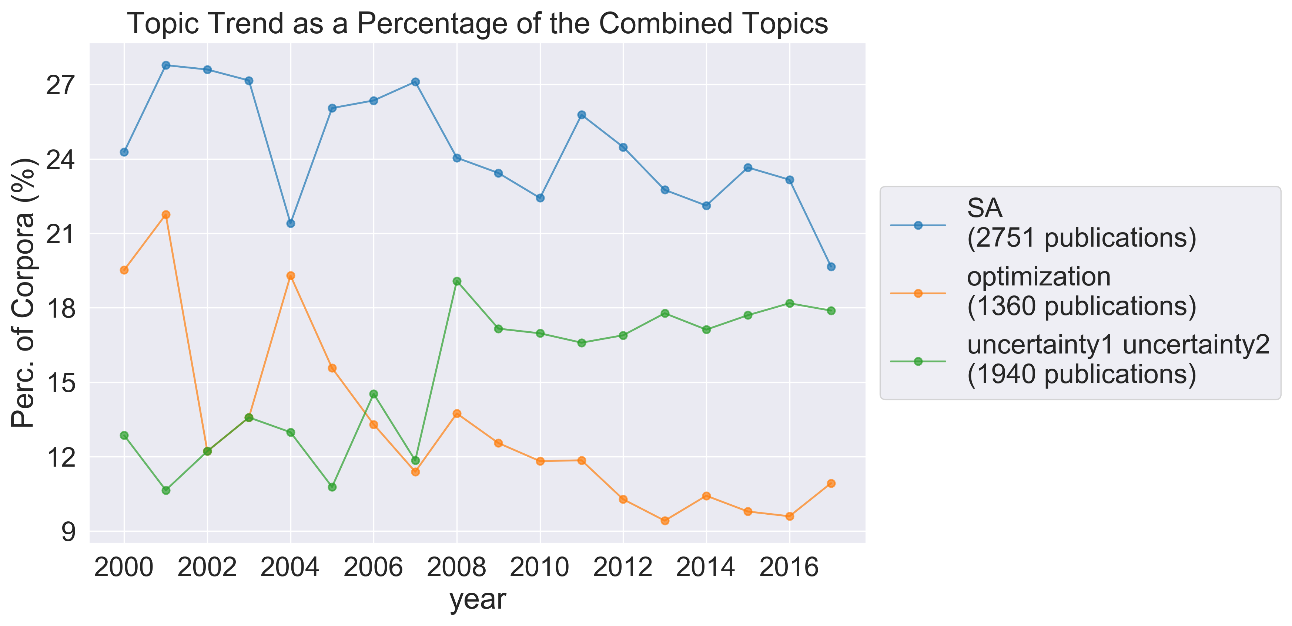

Top cited papers: Framework

|  |  |  |  |  |  |
| --- | --- | --- | --- | --- | --- |
| **Author** | **Year** | **Title** | **Journal** | **Citations** | **DOI link** |
| Bennett, ND|Croke, BFW|Guariso, G|Guillaume, JHA|Hamilton, SH|Jakeman, AJ|Marsili-Libelli, S|Newham, LTH|Norton, JP|Perrin, C|Pierce, SA|Robson, B|Seppelt, R|Voinov, AA|Fath, BD|Andreassian, V | 2013 | Characterising performance of environmental models | ENVIRONMENTAL MODELLING & SOFTWARE | 581 | https://dx.doi.org/10.1016/j.envsoft.2012.09.011 |
| Refsgaard, JC|van der Sluijs, JP|Hojberg, AL|Vanrolleghem, PA | 2007 | Uncertainty in the environmental modelling process - A framework and guidance | ENVIRONMENTAL MODELLING & SOFTWARE | 510 | https://dx.doi.org/10.1016/j.envsoft.2007.02.004 |
| Sigmund, O|Maute, K | 2013 | Topology optimization approaches A comparative review | STRUCTURAL AND MULTIDISCIPLINARY OPTIMIZATION | 384 | https://dx.doi.org/10.1007/s00158-013-0978-6 |
| Yang, J|Reichert, P|Abbaspour, KC|Xia, J|Yang, H | 2008 | Comparing uncertainty analysis techniques for a SWAT application to the Chaohe Basin in China | JOURNAL OF HYDROLOGY | 312 | https://dx.doi.org/10.1016/j.jhydrol.2008.05.012 |
| Blatman, G|Sudret, B | 2011 | Adaptive sparse polynomial chaos expansion based on least angle regression | JOURNAL OF COMPUTATIONAL PHYSICS | 253 | https://dx.doi.org/10.1016/j.jcp.2010.12.021 |
| Moens, D|Vandepitte, D | 2005 | A survey of non-probabilistic uncertainty treatment in finite element analysis | COMPUTER METHODS IN APPLIED MECHANICS AND ENGINEERING | 237 | https://dx.doi.org/10.1016/j.cma.2004.03.019 |
| van Dijk, NP|Maute, K|Langelaar, M|van Keulen, F | 2013 | Level-set methods for structural topology optimization: a review | STRUCTURAL AND MULTIDISCIPLINARY OPTIMIZATION | 201 | https://dx.doi.org/10.1007/s00158-013-0912-y |
| Shan, SQ|Wang, GG | 2010 | Survey of modeling and optimization strategies to solve high-dimensional design problems with computationally-expensive black-box functions | STRUCTURAL AND MULTIDISCIPLINARY OPTIMIZATION | 193 | https://dx.doi.org/10.1007/s00158-009-0420-2 |
| Kuczera, G|Kavetski, D|Franks, S|Thyer, M | 2006 | Towards a Bayesian total error analysis of conceptual rainfall-runoff models: Characterising model error using storm-dependent parameters | JOURNAL OF HYDROLOGY | 183 | https://dx.doi.org/10.1016/j.jhydrol.2006.05.010 |
| Chen, Y|Yu, J|Khan, S | 2010 | Spatial sensitivity analysis of multi-criteria weights in GIS-based land suitability evaluation | ENVIRONMENTAL MODELLING & SOFTWARE | 169 | https://dx.doi.org/10.1016/j.envsoft.2010.06.001 |

Top cited: Application

|  |  |  |  |  |  |
| --- | --- | --- | --- | --- | --- |
| **Author** | **Year** | **Title** | **Journal** | **Citations** | **DOI link** |
| Oudin, L|Hervieu, F|Michel, C|Perrin, C|Andreassian, V|Anctil, F|Loumagne, C | 2005 | Which potential evapotranspiration input for a lumped rainfall-runoff model? Part 2 - Towards a simple and efficient potential evapotranspiration model for rainfall-runoff modelling | JOURNAL OF HYDROLOGY | 322 | https://dx.doi.org/10.1016/j.jhydrol.2004.08.026 |
| Muleta, MK|Nicklow, JW | 2005 | Sensitivity and uncertainty analysis coupled with automatic calibration for a distributed watershed model | JOURNAL OF HYDROLOGY | 259 | https://dx.doi.org/10.1016/j.jhydrol.2004.09.005 |
| Pedersen, CBW|Buhl, T|Sigmund, O | 2001 | Topology synthesis of large-displacement compliant mechanisms | INTERNATIONAL JOURNAL FOR NUMERICAL METHODS IN ENGINEERING | 235 | https://dx.doi.org/10.1002/nme.148 |
| Le Maitre, OP|Knio, OM|Najm, HN|Ghanem, RG | 2004 | Uncertainty propagation using Wiener-Haar expansions | JOURNAL OF COMPUTATIONAL PHYSICS | 208 | https://dx.doi.org/10.1016/j.jcp.2003.11.033 |
| McVicar, TR|Van Niel, TG|Li, LT|Hutchinson, MF|Mu, XM|Liu, ZH | 2007 | Spatially distributing monthly reference evapotranspiration and pan evaporation considering topographic influences | JOURNAL OF HYDROLOGY | 202 | https://dx.doi.org/10.1016/j.jhydrol.2007.02.018 |
| Pappenberger, F|Beven, K|Horritt, M|Blazkova, S | 2005 | Uncertainty in the calibration of effective roughness parameters in HEC-RAS using inundation and downstream level observations | JOURNAL OF HYDROLOGY | 201 | https://dx.doi.org/10.1016/j.jhydrol.2004.06.036 |
| Gong, LB|Xu, CY|Chen, DL|Halldin, S|Chen, YQD | 2006 | Sensitivity of the Penman-Monteith reference evapotranspiration to key climatic variables in the Changjiang (Yangtze River) basin | JOURNAL OF HYDROLOGY | 196 | https://dx.doi.org/10.1016/j.jhydrol.2006.03.027 |
| Le Maitre, OP|Najm, HN|Ghanem, RG|Knio, OM | 2004 | Multi-resolution analysis of Wiener-type uncertainty propagation schemes | JOURNAL OF COMPUTATIONAL PHYSICS | 177 | https://dx.doi.org/10.1016/j.jcp.2003.12.020 |
| Oberkampf, WL|Barone, MF | 2006 | Measures of agreement between computation and experiment: Validation metrics | JOURNAL OF COMPUTATIONAL PHYSICS | 175 | https://dx.doi.org/10.1016/j.jcp.2006.03.037 |
| Stegmann, J|Lund, E | 2005 | Discrete material optimization of general composite shell structures | INTERNATIONAL JOURNAL FOR NUMERICAL METHODS IN ENGINEERING | 167 | https://dx.doi.org/10.1002/nme.1259 |

# UA/SA packages

Of great interest to this paper were the trends of software packages implementing UA/SA methods. In order to build a corpus of software-related publications, a keyword-matching algorithm was run on the corpora. The chosen keywords were “software” and “toolkit.” These were the most relevant keywords, justified by preliminary searches: other terms, such as package, were found to be superfluous or to pick up too many irrelevant publications. This yielded **[371]** papers. Running a key-phrase extraction algorithm on this collection more easily facilitated manual sorting. Manual sorting brought the corpus down to **[201]** papers. We will refer to this collection as “Software”. Papers were chosen as relevant if they included direct reference to UA/SA or optimization software packages; were theory, review, or framework papers which recommended software implementation to a given field; or referred to other methods and packages of interest to expert opinion, those being GLUE, PEST, PEST++, MODFLOW, HYDROMAD, and SWAT.

The use of software packages in UA/SA and optimization has seen a stable trend over the surveyed timeframe. Proportional to the corpora, there was a peak in publications in this field in 2007.

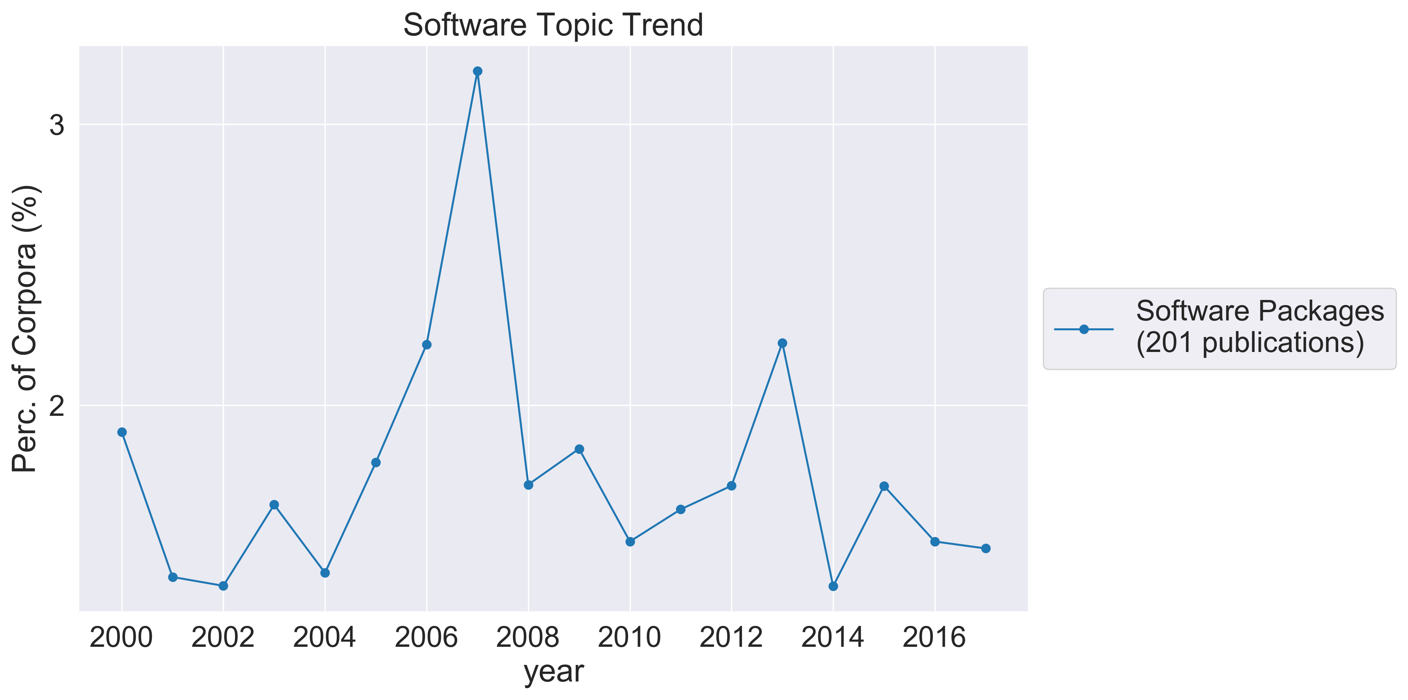

A keyword-matching algorithm was applied to the collection of packages in order to allocate papers to relevant field categories, these being Policy, Agriculture, Environment, Water, Socio-economic, Medicine, and Chemistry. The field categories were chosen based on scanning key-phrases from the Software collection. After sorting the papers into field categories, the key-phrase algorithm was again useful to determine which packages were being used by which fields, and for what purpose.

Papers relating to Policy were published in the fields of risk assessment; hydrological, environmental hazard, and waste management; population viability; and life cycle assessment. The papers addressed issues in modeling such as modelling with insufficient data or data with deep uncertainty; UA/SA; calibration; and decision analysis, especially regarding complex models.

Papers in the Agriculture category published research into emissions, irrigation, biogeochemical models, and agriculture-related life cycle assessments. The papers were concerned with SA, model development, and calibration.

Papers that met the Water criteria covered a variety of hydrological topics: drainage, water quality, groundwater, catchment management, storm discharge, stream-gauging data, infiltration, and flood forecasting. The packages mentioned were SWAT, DUET-H/WQ, PEST, SAKe, TOPMODEL, hydroPSO, SIMLAB, WaterRAT, GANetXL, MODFLOW, UTCHEM, MULINO-DSS (mDSS), ArCNLET, and PERSiST. The papers addressed modelling topics such as model design, development, and implementation; decision analysis and long-term planning; system integration; data recording, assimilation, and generation; UA/SA; uncertainty quantification (UQ); optimization; bootstrap confidence intervals; educational models; and probabilistic projection.

Papers in the Environment category included the environmental topics of ice-sheet mass, emissions, aerodynamics, soil, life cycle assessments, technologies, and population viability. The packages included were Day Cent, Ecological Risk-O-Meter, and DUE. This category was concerned with UA/SA; UQ; calibration; model design and integration; risk assessment; optimization; and assessing and simulating uncertain variables.

Papers that met the Socio-economic criteria published in environmental, management, and economic fields, including research into bio-oil; hydropower installation; urban drainage; renewable energy systems and sources; managed hospital care; life cycle assessment; and setup cost. These papers were concerned with techno-economic analysis; SA; model design and parallelization; optimization; feasibility analysis; and enviro-economic analysis.

Papers that met the Medicine criteria included research into heavy metal concentration in drinking water, cardiovascular analysis, cancer risk, and noise impact. These papers focused on aspects of modelling such as spatial analysis, (health) risk assessment, model development, frameworks, and UA.

Finally, those meeting the Chemistry criteria included research into biogeochemical models; tracer concentration; soil solution concentration; chemical kinetic systems; chemical persistence and long-range transport; (sustainable) chemical processes; bio-oil upgrading; plasma-assisted methane steam reforming; and wastewater. The packages mentioned were Day Cent, ChemKIN-PRO, TAMkin, and ArcNLET. They concerned modelling topics such as model development, calibration, UA/SA, parameter screening, decision analysis, optimization, and retrofit analysis.

A keyword-match was used to identify those papers in the Software collection that were implementing UA, SA, and optimization methods. The packages are most commonly implementing UA/SA methods. The keyword and publication trends show increased publications in all three areas in the years 2012-2017, and a spike in publications in 2007. Prior to these 2012 and excluding 2007, optimization papers had limited publications with little increase, SA publications had an increasing trend, and UA publications had a generally increasing trend.

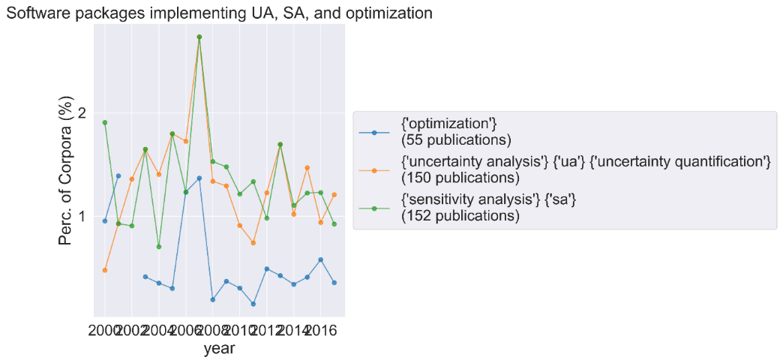

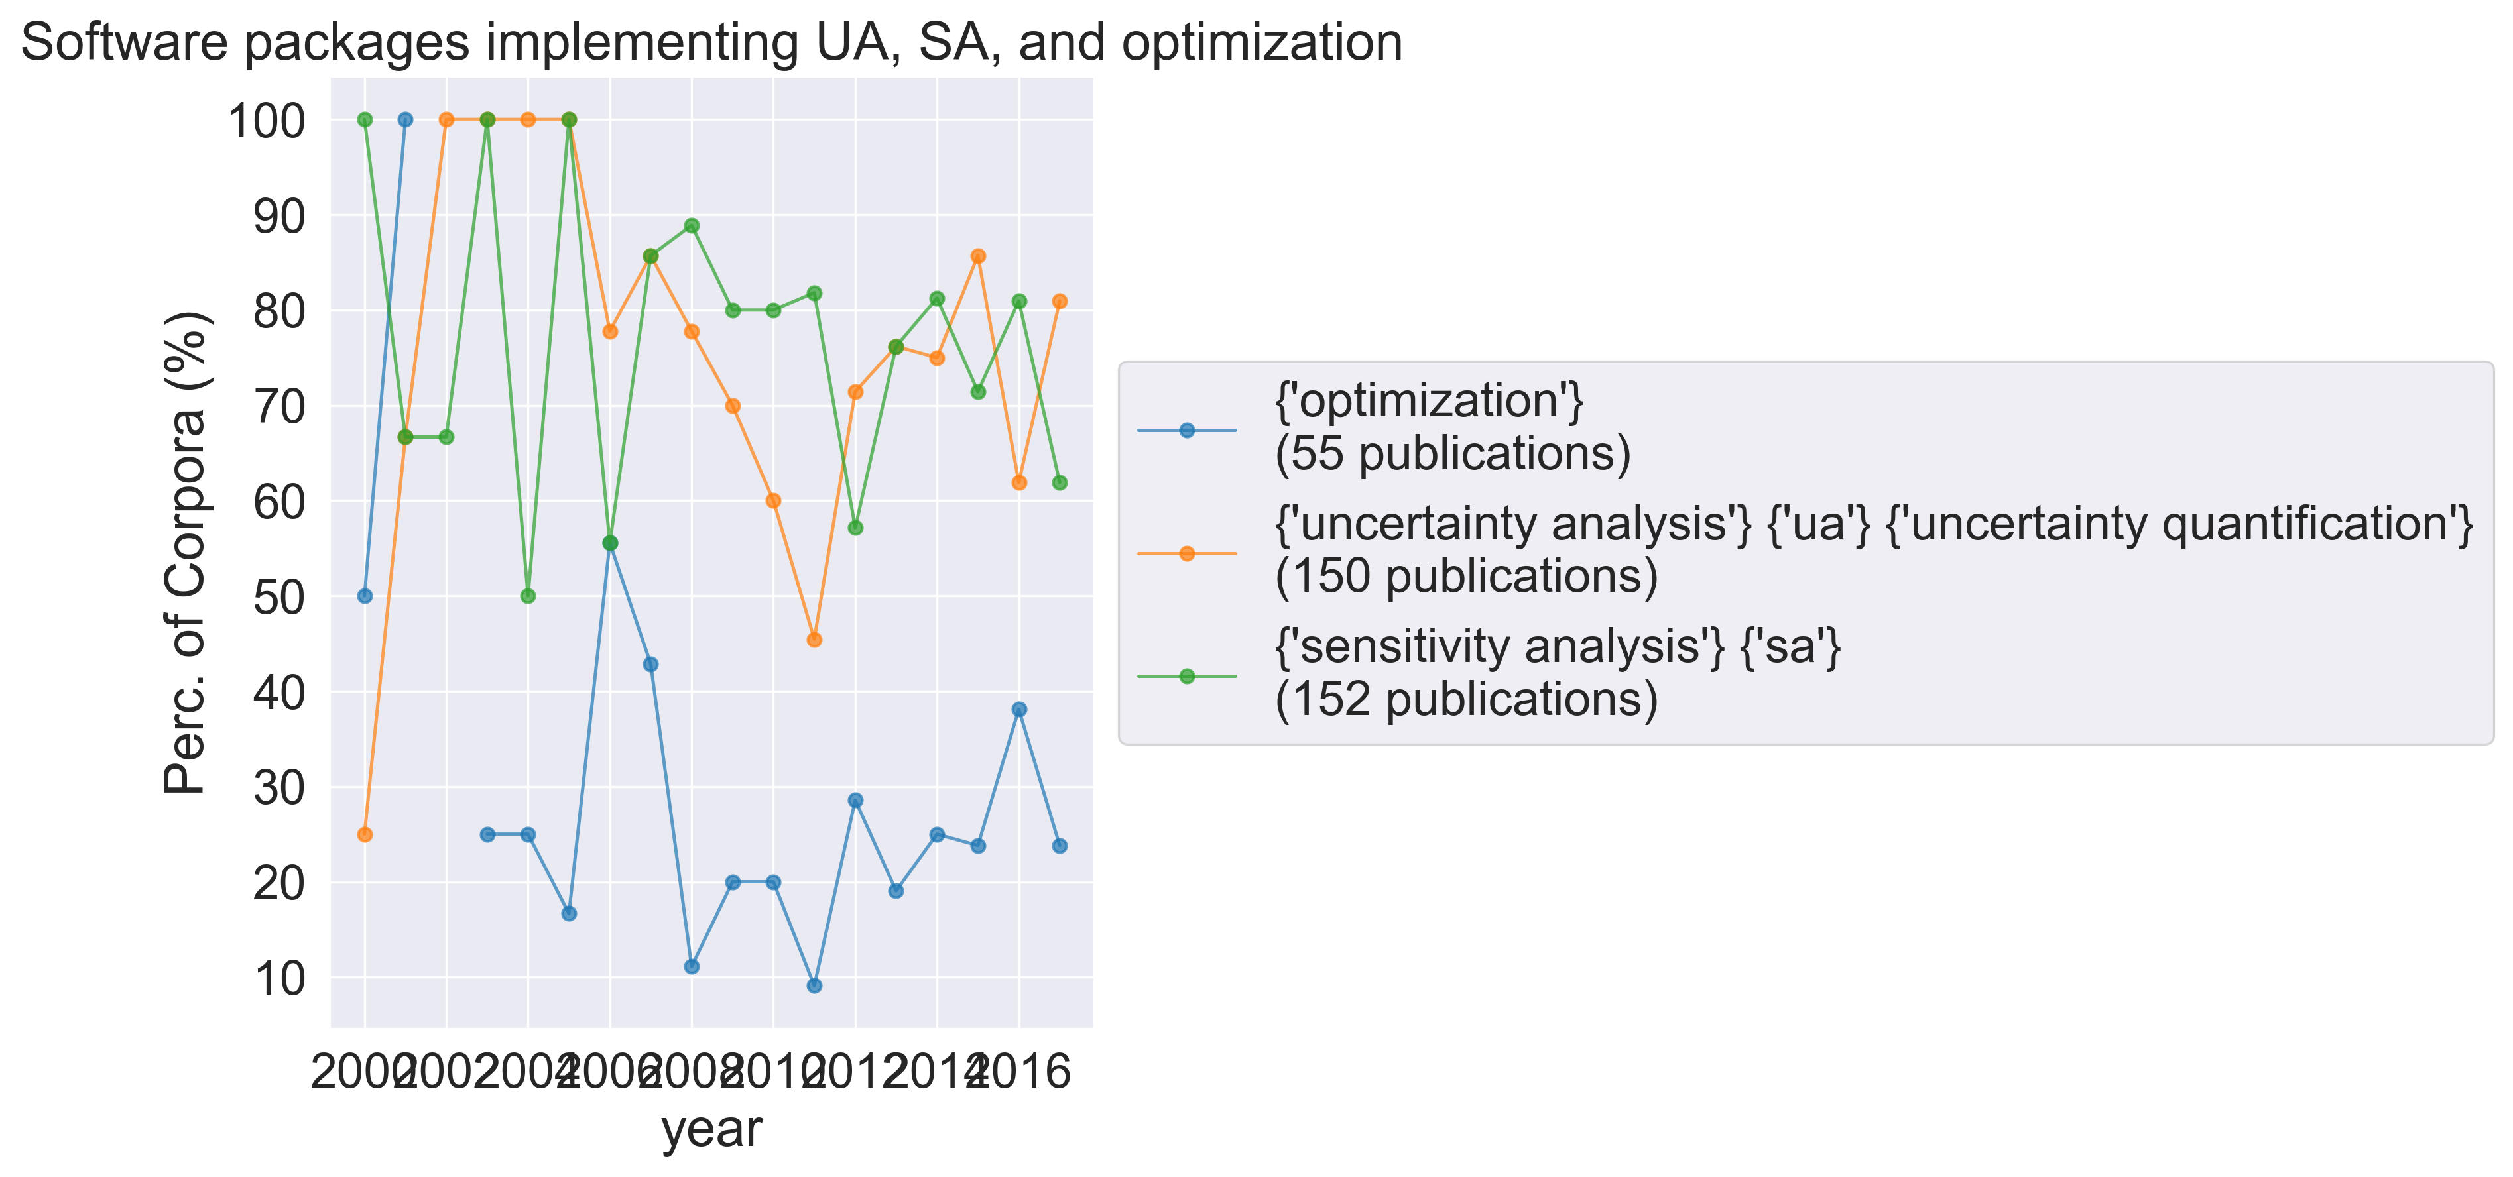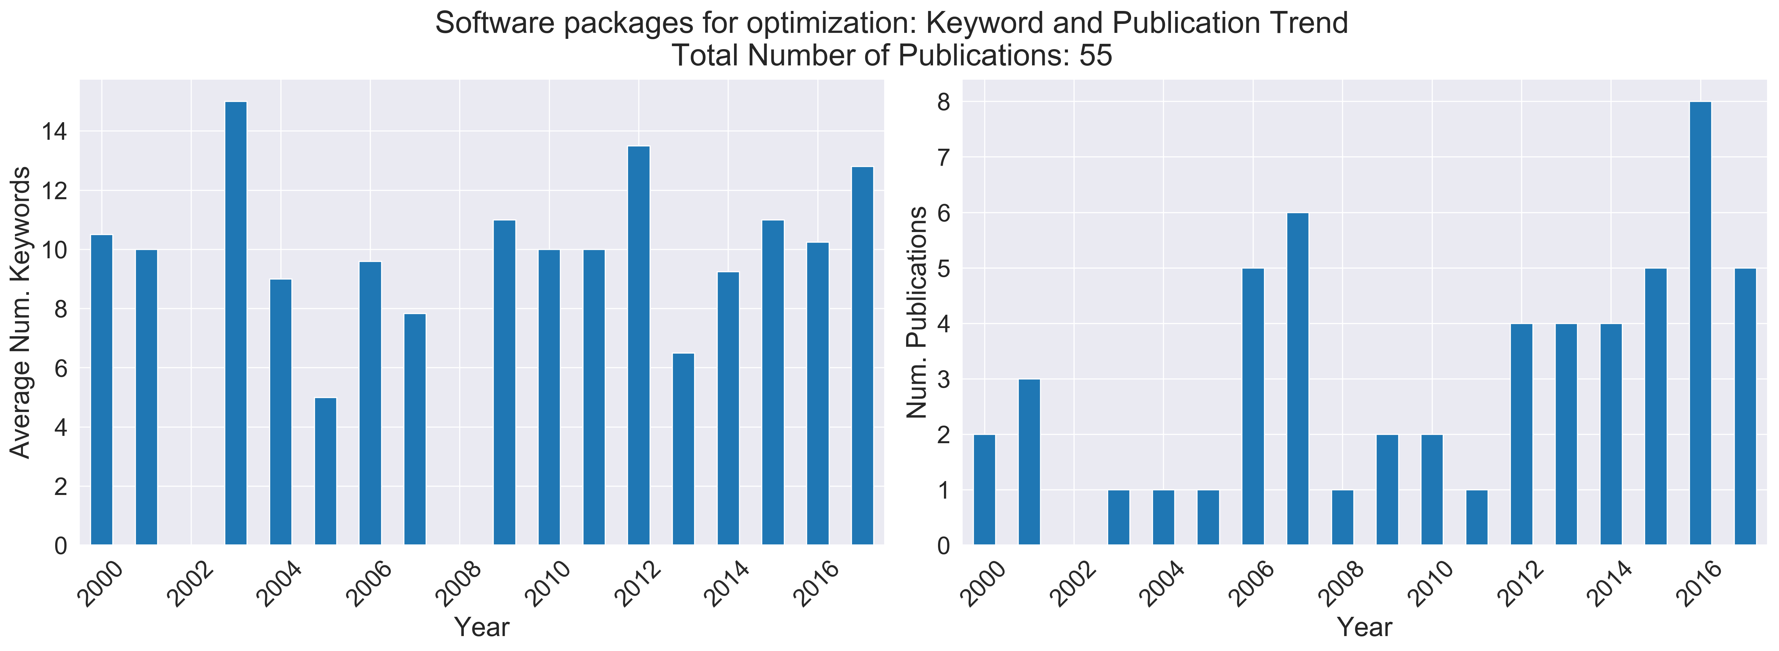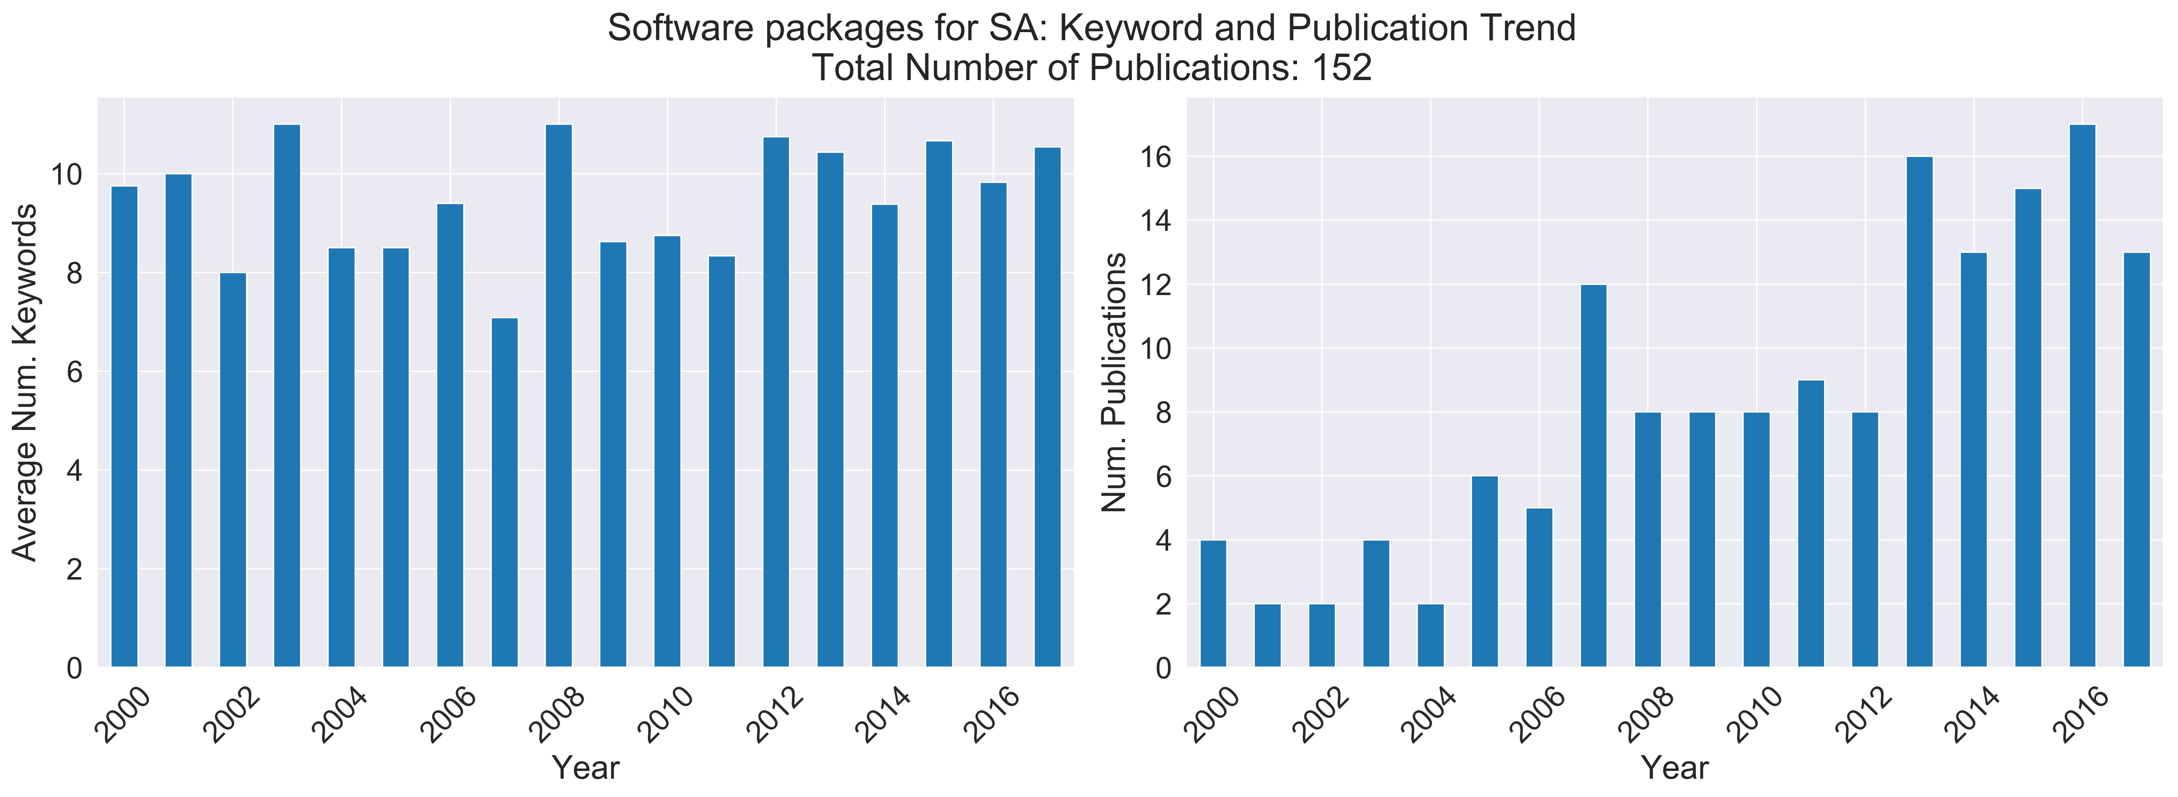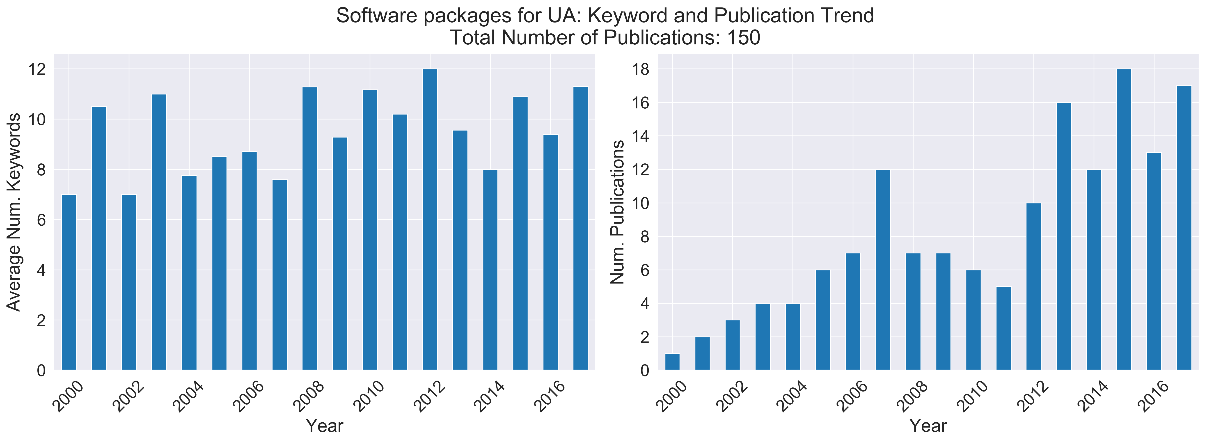

It was mentioned previously that current trends have shown an increased interest in best practices. Three SA packages, released within the past five years, reflect these changing attitudes: PSUADE (Gan et al., 2014), SAFE (Pianosi et al., 2015), and VARS-TOOL (Razavi et al., 2019).

PSUADE (a Problem Solving Environment for Uncertainty Analysis and Design Exploration) provides users with implementations of uncertainty quantification methods, including sampling techniques and SA methods (both local and global). The package has had general application to various modelling scenarios.

SAFE (Sensitivity Analysis For Everybody) provides users with implementations of global SA methods, with the ability to perform multiple SAs, robustness assessment, and convergence analysis without further model runs. As reflected in its name, this package was designed to allow global SA to be accessible to a more general audience.

The most comprehensive package in the survey, VARS-TOOL, provides implementations of sampling techniques and global SA methods, including derivative-, variance-, and variogram-based, which can all be performed from a single sample. The developers claim that the variogram-based SA approach links both local and global approaches to SA.

Top cited papers: software packages

|  |  |  |  |  |  |
| --- | --- | --- | --- | --- | --- |
| **Author** | **Year** | **Title** | **Journal** | **Citations** | **DOI link** |
| Ziehn, T|Tomlin, AS | 2009 | GUI-HDMR - A software tool for global sensitivity analysis of complex models | ENVIRONMENTAL MODELLING & SOFTWARE | 120 | https://dx.doi.org/10.1016/j.envsoft.2008.12.002 |
| Gallagher, M|Doherty, J | 2007 | Parameter estimation and uncertainty analysis for a watershed model | ENVIRONMENTAL MODELLING & SOFTWARE | 118 | https://dx.doi.org/10.1016/j.envsoft.2006.06.007 |
| Clavreul, J|Baumeister, H|Christensen, TH|Damgaard, A | 2014 | An environmental assessment system for environmental technologies | ENVIRONMENTAL MODELLING & SOFTWARE | 77 | https://dx.doi.org/10.1016/j.envsoft.2014.06.007 |
| Gan, YJ|Duan, QY|Gong, W|Tong, C|Sun, YW|Chu, W|Ye, AZ|Miao, CY|Di, ZH | 2014 | A comprehensive evaluation of various sensitivity analysis methods: A case study with a hydrological model | ENVIRONMENTAL MODELLING & SOFTWARE | 72 | https://dx.doi.org/10.1016/j.envsoft.2013.09.031 |
| Cannavo, F | 2012 | Sensitivity analysis for volcanic source modeling quality assessment and model selection | COMPUTERS & GEOSCIENCES | 71 | https://dx.doi.org/10.1016/j.cageo.2012.03.008 |
| Harmel, RD|Smith, DR|King, KW|Slade, RM | 2009 | Estimating storm discharge and water quality data uncertainty: A software tool for monitoring and modeling applications | ENVIRONMENTAL MODELLING & SOFTWARE | 64 | https://dx.doi.org/10.1016/j.envsoft.2008.12.006 |
| Wegmann, F|Cavin, L|MacLeod, M|Scheringer, M|Hungerbuhler, K | 2009 | The OECD software tool for screening chemicals for persistence and long-range transport potential | ENVIRONMENTAL MODELLING & SOFTWARE | 60 | https://dx.doi.org/10.1016/j.envsoft.2008.06.014 |
| Sinha, K | 2007 | Reliability-based multiobjective optimization for automotive crashworthiness and occupant safety | STRUCTURAL AND MULTIDISCIPLINARY OPTIMIZATION | 58 | https://dx.doi.org/10.1007/s00158-006-0050-x |
| Shin, MJ|Guillaume, JHA|Croke, BFW|Jakeman, AJ | 2013 | Addressing ten questions about conceptual rainfall-runoff models with global sensitivity analyses in R | JOURNAL OF HYDROLOGY | 56 | https://dx.doi.org/10.1016/j.jhydrol.2013.08.047 |
| Brown, JD|Heuvelink, GBM | 2007 | The Data Uncertainty Engine (DUE): A software tool for assessing and simulating uncertain environmental variables | COMPUTERS & GEOSCIENCES | 51 | https://dx.doi.org/10.1016/j.cageo.2006.06.015 |

## Comparison of surveyed packages

### SimLab

SimLab is a package for Monte Carlo-based SA, written in Matlab and supplied by the Joint Research Centre. It provides Monte Carlo and other random sampling methods, and test functions for educational purposes. The SA is applied as a black-box on model output. The use of HPC is not mentioned in the documentation and there is no option for GUI. It is freely available for academic use, but not open source. No user community appears to exist. The documentation consists of a reference manual.

* Simulation Laboratory for UA/SA
* Screening, correlation-, regression-, and varance-based SA, MC and stratified sampling
* Src, manual and executables available.
* Software available by web download
* Development framework particularly for UA/SA

### GUI-HDMR

(Graphical user interface-high dimensional model representation)

This is a SA package written in Matlab, however it is a loose-coupled package: users supply input and output files in ASCII files. The user must supply an appropriate sample of the model output (some indication is given in the provided documentation as to which sampling methods are appropriate, and there is a complementary package, RS-HDMR [random sampling-HDMR]) and SA and objective functions are applied to the given data. The SA provided is HDMR, a variance-based SA method, which the developers advertise as a competitive alternative to other recently developed SA methods, such as random balance design. The use of HPC is not mentioned in the documentation. Users have the choice of GUI or a script-based interface. The software is user-friendly and has been applied to various fields. It is freely available for academic use, but not open source. No user community appears to exist, but there is user documentation.

### Dakota

The Dakota toolkit was initially developed to provide a package of optimisation tools for engineers. It has now been developed further to include global SA methods, parameter estimation, and UQ. The software can operate as close-, semi-, or loose-coupled to the model simulation, requiring the user in the first two cases to modify their code or use a direct interface. In the most common usage of Dakota, SA is applied as post-processing to model outputs. Various sampling methods are supplied, and the SA methods supported include design of experiments and parameter studies. The package is presented as being accessible to beginners and involves advanced features for more competent users. The package operates on Linux, Windows, and Unix. Parallelisation is possible and there is a GUI option. It is freely available for academic use and open source. A user community exists, including mailing lists and interaction with developers. Documentation includes user manuals, examples, and release notes.

* (as of 2009) local SA
* MC, stratified sampling, and approximate UA
* Local, global, and hybrid parameter estimation
* Src, manual, and executable available.
* Available for web download
* <http://dakota.sandia.gov/index.html>
* Toolkit implementing algorithms for optimization, experimental design, and UQ.

### PSUADE

PSUADE is a SA package available in C++, with the ability to link to simulation code in any language. It provides users with 14 sampling methods and 12 SA methods, including both local and global SA. It was developed for large complex systems models, and has been successfully applied to various fields. The software has a free public licence and is open source. A collaborative user community exists. Documentation includes a user manual. It does not have HPC or GUI capabilities.

### UQLab

This package provides, among other tools for UQ, tools for statistical analysis, such as sampling and global SA. Global SA methods are also supplied through a linkage with the Sensitivity Package written in R. The package operates via loose-coupling to the model, applying the SA as a black-box on model input and output. Parallelisation is supported. The package is user friendly and adaptable to various levels of computational experience. Collaboration amongst users is encouraged and users can contribute to code, with revision by the major developers. It is portable between operating systems, and freely available for academic use, however documentation is not freely available.

### SAFE

This SA package is implemented in Matlab, is compatible with the GNU Octave environment, and a version implemented in R also exists. It runs on any operating system. The toolbox was designed to make global SA accessible to users with limited knowledge of global SA or Matlab, whilst also allowing more advanced users to explore, research, and better understand SA. Users are provided with various sampling methods, and local and global SA methods. Although there is no collaborative user community, it is designed to facilitate integration of new methods and code for personal use, and it is easy to use only portions of the supplied code. The use of HPC is not mentioned in the documentation. Users have the choice of GUI. The software is freely available for academic use and is open source. Documentation includes the companion paper (Pianosi et al., 2015) and additional information provided in workflow scripts.

### R - Sensitivity package

This is a package of SA methods written in the programming language R. It can be coupled with models written in R, and there is a de-coupling option for models in other languages. Various SA methods are supplied (need to figure out if sampling is intrinsic in the method or there is an assumption to use a sampling package). Test cases are supplied for research and comparison purposes. HPC capabilities are undocumented, and there is no GUI. The package assumes knowledge of R. It is portable between operating systems, freely available (free public licence and open source), and stored in the repository CRAN. A developer community exists. Documentation consists of a reference manual.

### VARS-TOOL

VARS-TOOL is a package in Matlab, C++, and OSTRICH (a user-independent interface). it features off-line and on-line mode options for running models in any language or operating system. Numerous sampling and SA methods are supplied, including VARS, which is claimed to comprehensively link existing SA methodologies. It is user-friendly and accessible to various levels. Although it is continually in development, there is no collaborative community. The software if freely available for non-commercial use and is open-source. There are capacities for parallelisation and reporting and visualisation tools. No user or developer community exists. Documentation consists of a manual.

### SALib

SALib is a SA package implemented in Python, providing global SA methods to be performed after model runs. It provides users with first and total order sensitivity indices with bootstrap confidence intervals, and tools to generate samples associated with model inputs, to analyse outputs, and to visualise results. It is a freely available, open-source package, with a collaborative user community, including 13 contributors. SALib is well-documented: documentation includes an installation guide, basic usage, a concise API reference of the sensitivity analysis methods supported, a complete module reference, and a history of changes. There are no capabilities for HPC. The software has a free public licence and is open-source.

### MADS

MADS is a SA package available in the programming language Julia. The analyses it supports can be internally or externally coupled with the existing model simulator. In the module documentation, extensive information is provided for all functions included in the main module, Mads.jl. Included in the module are sampling techniques, optimization techniques, and sensitivity analysis methods. The documentation details methods, arguments, return, sources, keywords, and examples. Although extensive, the layout is not user-friendly, and would benefit from being grouped and linked into subcategories. Less obvious functions lack meaningful descriptions. MADS works in an HPC framework, allowing users the ability to perform HPC on multi-processor clusters and parallel environments. It is a freely available, open-source package, with a collaborative user community, including 13 contributors.

An inherent advantage of the software is that the underlying language it was developed in (Julia) is a young language – it reached v1.0 in 2018. Due to its relative youth, it leverages lessons learnt in older programming languages and was developed with modern computational architecture in mind. This means that concurrent and parallel programs are relatively easy to develop in Julia **(ref the Julialang paper)** and has had demonstrable success on High-Performance Computing platforms. The disadvantage of this youth, however, is that the user community – while growing quickly as demonstrated by **[several indexes that track these things] –** is still relatively small compared to that of established languages. As such the language ecosystem may still be immature and undergoing continual development.

Here are some notes on the other packages picked up by the corpora. Packages missing from this collection include MADS/Julia, VARS, and active subspaces, and there are less Simlab, Sandia, and DAKOTA papers in the collection. The packages found through key-phrase extraction are largely optimization and modelling software, especially for application in a specific, rather than generalized, field (e.g. water quality modelling, groundwater, etc.). Some of this information is incomplete, may need to download the software/user’s manuals to fill it in.

GLUE

* Release date: 1992 (2013)
* Language: implementations in R and Matlab/Octave
* Related publication: Beven, K J, *Environmental Modelling: An Uncertain Future?* Routledge:London, 2009 is referenced on supporting website.  The original publication is <https://doi.org/10.1002/hyp.3360060305> (1992), with a follow up paper written in 2014: <https://doi.org/10.1002/hyp.10082>
* Comments: Not a package but a method implemented in supporting software, ie R package provided by developers, Matlab/Octave packages are written by other developers implementing the method.
* Screening, importance sampling for UA and parameter estimation.
* Manual and executable available, software available for web download.
* Community: nil
* Docs: <http://www.uncertain-future.org.uk/?page_id=28>; this is R package documentation.  Documentation for Matlab/Octave found in the relevant software’s documentation.
* Link to repo: nil

PEST

* Parameter EStimation Toolkit
* Release date: ?
* Language: C, C++, FORTRAN, Python
* Related publication: there’s this: <http://www.pesthomepage.org/PEST-The_Book.php>
  + Doherty, J. (2004), PEST: Model‐Independent Parameter Estimation, User Manual, 5th ed., Watermark Numer. Comput., Brisbane, Queensland, Australia.
* Comments: parallelization options, no GUI
* Open access: Source code available with Unix download.
* Community: No user community appears to exist but user-developer support is offered, training courses provided.
* Docs: well documented, website current (last update 01/01/2019), tutorial included.
* Link to repo: nil
* Calibration, regularization, optimization, MC UA (local SA), parameter identification and error variance, importance sampling and approximate UA.

SWAT

* Release date: 2000 (2018)
* Language: ?
* Related publication:
* Comments: A catchment model, not a UA/SA package; externally developed interfaces/tools use SWAT, including interfaces implementing GUUI and UA/SA methods.
* Open access:  public domain program, source code possibly included in download.
* Community: User community groups exist for SWAT, its interfaces, and various user nationalities, which are monitored by a development team.  There is also user-developer engagement, workshops/conferences.
* Docs: Documentation of user inputs.
* Link to repo: nil

DUET-H/WQ

* Data Uncertainty Estimation Tool for Hydrology and Water Quality
* 2008 ()
* Never explicitly states language or platform. Appears to be more of a Windows application.
* No HPC, GUI, parallelization
* Difficult to ascertain whether open access or community exists.
* *Harmela, R. D. et al. “Data Uncertainty Estimation Tool for Hydrology and Water Quality (DUET-H / WQ): Estimating Measurement Uncertainty for Monitoring and Modelling Applications.” (2008).*
* Software does not appear to have been updated or in continual use. No link to repo/src available.
* TODO: look up references in corpora papers using DUET-H/WQ

DUE

* Data Uncertainty Engine
* Population, geospatial, and time series data analysis.
* Src, manual, and executable available.
* Software available for web download, General Public Licence
* Publication doi: 10.1016/j.cageo.2006.06.015 (link to source code in publication has expired)
* 2006
* Java

SAKE

* Best I could find was <https://www.researchgate.net/publication/236162159_CM_SAKe_A_Hydrological_Model_to_Forecasting_Landslide_Activations>
* Self Adapting Kernel
* Is a hydrological model of landslides

TOPMODEL

* “It is a semi distributed conceptual rainfall runoff model that takes the advantage of topographic information related to runoff generation.”
* *Beven KJ*, *Lamb R*, *Quinn PF*, *Romanowicz R*, *Freer J*. *1995*. *TOPMODEL*. In *Computer Models of Watershed Hydrology*, *Singh VP* (ed.). Water Resources Publications: *627*–*668*.
* Rainfall-runoff model
* https://onlinelibrary.wiley.com/doi/epdf/10.1002/hyp.252

hydroPSO

* R package
* Particle swarm optimization
* <https://cran.r-project.org/web/packages/hydroPSO/index.html>
* Open source and community

WaterRAT

* Water quality Risk and Assessment Tool
* 2004
* Surface-water quality assessment tool
* A library of river and lake quality models, sources of uncertainty can be included in the model, facilitates UA/SA and data collection.
* Spread-sheet based modelling tool (Microsoft Excel)
* No indication as to whether the programme is open source, no link to source code/repo, no link to download.
* <https://www.google.com/url?sa=t&rct=j&q=&esrc=s&source=web&cd=11&ved=2ahUKEwjNqvbCjLLgAhWOWX0KHT6vChQQFjAKegQIBRAB&url=https%3A%2F%2Fscholarsarchive.byu.edu%2Fcgi%2Fviewcontent.cgi%3Farticle%3D3538%26context%3Diemssconference&usg=AOvVaw2UK8TgbATrDmIja-dybAFL>

GANetXL

* 2006 (paper released 2011, last release date unspecified)
* General-purpose decision support system generator (DSS), Microsoft Excel add-in.
* For multi-objective optimization of spreadsheet based models.
* GUI
* Free for non-commercial use, <http://www.exeter.ac.uk/cws/ganetxl>
* Spreadsheets from documentation made available.
* No link to src/repo
* Community of users on Linkedin.
* Documentation: <http://dx.doi.org/10.1016/j.envsoft.2010.11.004>, user manual, presentation.

MODFLOW

* Open source, source code provided with documentation: <https://water.usgs.gov/ogw/modflow/MODFLOW.html>
* 1984 (2018)
* User-developer interaction encouraged.
* Doesn’t mention language, download is for Microsoft Windows (**see documentation?**)

UTCHEM

* Chemical flooding simulator
* Latest user guide release 1996. Updates/additional features have been added but there is no src/repo/documentation. Original formulation in a publication from 1989.
* FORTRAN
* Distributed memory parallel computers
* Documentation: <https://www.osti.gov/servlets/purl/281959>

MULINO-DSS/mDSS

* DSS for solving decision problems in water resource management.
* Socio-economic and environmental mdoels, GIS, multi-criteria decision aids.
* EU Water Framework Directive
* 2004 (2010?)
* <http://www.netsymod.eu/mdss/>
* User guide and description of decision methods provided with software download.
* No indication to licence agreement, language, user communication.
* Compatible with Windows operating systems.

ArcNLET

* 2011 (2013)
* Free for commercial and non-commercial use but not open source.
* Documentation: user, technical, and application manual, UA/SA guide, and sample data.
* Groundwater nitrate fate and transport model.
* GIS-based screening tool, estimate nitrate loads to surface water bodies from onsite wastewater treatment systems.
* No indication of language or operating system.
* <https://people.sc.fsu.edu/~mye/ArcNLET/>

PERSiST

* 2013
* Precipitation, Evapotranspiration and Runoff Simulator for Solute Transport
* Flexible, semi-distributed landscape-scale rainfall-runoff modelling toolkit.
* For use with INCA models.
* Documentation: [www.hydrol-earth-syst-sci.net/18/855/2014/](http://www.hydrol-earth-syst-sci.net/18/855/2014/)
* Possible a Markov Chain Monte Carlo SA tool provided.
* No indication of user licence agreement, gui, hpc, user community, src/repo.

Day Cent

* Daily time-step version of the CENTURY model (biogeochemical).
* Simulates carbon and nitrogen fluxes, sub-models for soil moisture etc.
* Access to model on request.
* 1994? (2013)
* No indication of language, user licence agreement, user community, gui, hpc, src/repo.
* Documentation: release notes, instructions (setup and use), understanding the model, development overview, simulations. <https://www2.nrel.colostate.edu/projects/daycent-downloads.html>

Ecological Risk-O-Meter (Eco-RoM)

* Risk assessment and management software tool.
* Includes cost optimization methods.
* No indication of src/repo, licence agreement, user community, language.
* No gui/hpc

ChemKIN-PRO

* Gas-phase and surface chemistry model
* 1980s-present
* Not free for use.
* No indication of src/repo, licence agreement, user community, language.
* GUI, parallelization.
* https://www.ansys.com/products/fluids/ansys-chemkin-pro

TAMkin

* <http://dx.doi.org/10.1021/ci100099g>
* Documentation includes installation, problem-solving, getting started, generating and loading data, chemical physics tutorials, programmer’s guide, library and module index. <http://molmod.github.io/tamkin/>
* Free and open source software, GNU General Public Licence.
* Post-processing toolkit for normal mode analysis, thermochemistry, and reaction kinetics.
* 2013 (2017)
* Python
* No indication of user community.

JUPITER (Joint Universal Parameter Identification and Evaluation of Reliability) API

* Banta, E. R., E. P. Poeter, J. E. Doherty, and M. C. Hill (Eds.) (2006), JUPITER: Joint Universal Parameter Identification and Evaluation of Reliability — An application programming interface (API) for model analysis, U.S. Geol. Surv. Tech. Methods, *TM 6‐E1*.
* 11 FORTRAN-90 modules
* To improve model analysis software development.
* Pre-existing modules implemented internally or externally to subroutines.
* Parallel processing capabilities.
* 2006 (2013)
* Local SA and parameter estimation
* <http://water.usgs.gov/software/JupiterApi>
* Documentation: module description and example applications; src, manual, and executables available, software available for web download.
* Developer-user support for bug-fixing.

OSTRICH

* Optimization Software Toolkit for Research in Computational Heuristics
* <http://www.eng.buffalo.edu/~lsmatott/Ostrich/OstrichMain.html>
* Calibration, optimization, parameter correlation, UA/(local)SA, observation influence, GLUE, quantitative multimodal analysis.
* Google group for users, particularly for hydrological model auto calibration.
* Parallel-processing
* Matott, LS. 2017. *OSTRICH: an Optimization Software Tool, Documentation and User's Guide, Version 17.12.19*. 79 pages, University at Buffalo Center for Computational Research, [www.eng.buffalo.edu/~lsmatott/Ostrich/OstrichMain.html](http://www.eng.buffalo.edu/~lsmatott/Ostrich/OstrichMain.html).
* ? (2017)
* Src available with user manual and demos.

PEAS

* Parameter Estimation Accuracy Software
* Local SA and parameter estimation
* 2005 (?)
* Matlab
* Model assessment tools, parameter estimation, MC analysis, trajectory SA, reliability assessment (confidence intervals).
* Freely available for academic use, at user’s request.
* No indication of community, link to repo/src
* GUI

UCODE

* Universal CODE for inverse modelling
* Local SA, approximate UA, and global parameter estimation
* Link to src: https://igwmc.mines.edu/ucode/
* Relevant publication: <https://doi.org/10.1016/S0098-3004(98)00149-6>
* Programmed in perl, a freeware language for text manipulation and FORTRAN90
* Calibration, parameter estimation, and UQ.
* 2005 (2015): UCODE-2005 and UCODE_2014, latter constructed using JUPITER API.
* Documentation: manual

UNCSIM

* UNcertainty SIMulator
* Local SA, MC, stratified, and importance sampling
* Publication: Reichert, P. (2006), A standard interface between simulation programs and systems analysis software, *Water Sci. Technol.*, 53(1), 267–275, doi:[10.2166/wst.2006.029](https://doi.org/10.2166/wst.2006.029).
* 2006 (?)
* Interface between systems analysis software and simulators.
* Built on text file interface.
* Maximum likelihood parameter estimation, multivariate distribution sampling.
* Indication that software is free for academic and commercial use
* No link to src/repo, no indication of existing community

MCAT

* Monte Carlo Analysis Toolbox
* Screening and correlation-based SA, temporal and behavioral identification analysis
* 2001 (2014)
* Matlab
* GUI
* Parameter, model structure, and output uncertainty, SA, GLUE, PARETO.
* User manual: <https://www.researchgate.net/publication/267818673_Monte-Carlo_Analysis_Toolbox_User_Manual>
* No indication of user community, link to repo/src. Did find an unofficial github page.
* Src, manual, executables, and software available for web download.

MOGSA

* MultiObjective Generalized Sensitivity Analysis
* Correlation-based SA
* Algorithm
* 1998
* Publication: Bastidas, L. A., H. V. Gupta, S. Sorooshian, W. J. Shuttleworth, and Z. L. Yang (1999), Sensitivity analysis of a land surface scheme using multicriteria methods, J. Geophys. Res., 104, 19,481– 19,490.
* Limited information available: search for software implementing algorithm. Appears to be literature supporting extensions of the algorithm.
* Src available (?), software available on request

RIMME

* Random-search Inverse Methodology for Model Evaluation
* Correlation-based SA and importance sampling.
* Regionalized SA, tree-structured density estimation, uniform covering by probabilistic rejection.
* Integrates quantitative uncertainty with qualitative (e.g. stakeholder) uncertainty into model analysis.
* Publication: doi: 10.1080/1389517049051541
* 2003
* Software and src available by web download but could not be found

SARS-RT

* Sensitivity Analysis based on Regional Splits and Regression Trees
* Correlation- and regression-based SA
* Software not available, method description only

GEM

* Gaussian Emulation Machine
* Variance-based SA, MC sampling, MCMC sampling.
* Manual and executable available, software available by web download.
* <http://www.tonyohagan.co.uk/academic/GEM/>
* Free for non-commercial use.
* 2005 (2009)

Crystal Ball

* Spreadsheet-based
* Predictive modelling, forecasting, simulation, and optimization
* Not free

This paper from 2009 <https://agupubs.onlinelibrary.wiley.com/doi/full/10.1029/2008WR007301> had a comprehensive table of the software available to date, and categorised their SA capabilities by screening, local, correlation-, regression-, and variance-based SA. Also picked out packages of interest.

Layout of 2009 paper could inform this one.

<https://www.sciencedirect.com/science/article/pii/S2214241X15001273> mentions common models in hydrology prior to 2015: TOPMODEL, HBV, VIC, SWAT.

<https://www.sciencedirect.com/science/article/pii/S1364815213002211> application of SWAP.

Search for the above papers and the mentioned packages/models.

Article of interest:

Wagener etal., 2003. A hydroarchive for the free exchange of hydrological software Website. Hydrological Processes. v18 i2. 389-391.

Website link is: <http://web.sahra.arizona.edu/software/alt/index.html> Appears to have been abandoned ca. 2005.

# Quick Comparison Table

|  |  |  |  |  |  |  |  |  |
| --- | --- | --- | --- | --- | --- | --- | --- | --- |
| Name | First (and Last) Release | Language | Related publication | Comments | Open Access? | Community | Docs | Link to repo/src |
| SimLab | 1985 (2008) | Matlab | (JRC, 2015) | The use of HPC is not mentioned in the documentation.  There is no option for GUI. | Freely available for academic use, but not open source.  End user free licence. | No community appears to exist. | Reference manual. |  |
| GUI-HDMR  (Graphical user interface-high dimensional model representation) | 2008  (2008) | Matlab | (Ziehn and Tomlin, 2009) | The use of HPC is not mentioned in the documentation.  Users have the choice of GUI or a script-based interface. | Freely available for academic use, but not open source. | No community appears to exist. | User documentation. |  |
| Dakota | 2014  (2018) | C, C++, Fortran77, Fortran90 | (Adams et al., 2010) | Parallelisation is possible and there is a GUI option. | Freely available for academic use, open source with various levels of user interaction. LGPL from version 5.0. | A user community exists: mailing list and interaction with developers. | User’s, reference, developer’s, theory, GUI manual. | <https://dakota.sandia.gov/content/getting-dakota-source-code> |
| PSUADE | 2014  (2018) | C++ | (Gan et al., 2014) | NO HPC or GUI. | Free public licence, open source. LGPL. | A user community exists. | User manual. | <https://github.com/LLNL/psuade> |
| UQ Lab | 2014?  (2018) | Matlab, R linkage | (Marelli and Sudret, 2014) | Parallelisation is possible but there is no GUI option. | Freely available for academic use. Content management system is licensed, scientific modules are open source. | No user community appears to exist, there is a developer community. | User manuals, examples, release notes. |  |
| SAFE | 2015  (2015) | Matlab, Octave | (Pianosi et al., 2015) | The use of HPC is not mentioned in the documentation.  Users have the choice of GUI. | Freely available for academic use, open source. | No user community appears to exist. | Pianosi et al, more information provided in workflow scripts. |  |
| R - Sensitivity package | 2018?  (2018) | R | (Iooss et al., 2018) | No HPC or GUI. | Free public licence (GPL-2), open source. | No user community exists, a developer community exists. | Iooss et al (reference manual). | <https://www.rdocumentation.org/packages/sensitivity/versions/1.15.2/source> |
| VARS-TOOL | 2016?  (2018) | Matlab, C++, OSTRICH | (Razavi et al., 2019) | Capacities for parallelization. Visualization tools available. | Free for non-commercial use, not open source. | No user or developer community exist. | Manual. | <http://vars-tool.com> |
| SALib | 2013  (2018) | Python | (Herman and Usher, 2017) | No HPC, visualisation tools available. | Free public licence (MIT), open source. | User community exists. | GitHub, ReadTheDocs. | <https://github.com/SALib/SALib> |
| MADS | 2016  (2018) | Julia | ? | HPC, no GUI. | Free public licence (GPL), open source. | User community exists. | GitHub, ReadTheDocs. | <https://github.com/madsjulia/Mads.jl> |

# Conclusion and Future Directions

* What are the gaps/what could be improved?
* To be revisited in this section:

*The most comprehensive package in the survey, VARS-TOOL, provided users with global sensitivity analysis, VARS, sampling methods, SA with time-variance, factor grouping, and measures of the robustness and convergence of the SA, model emulation, visualisation tools, and test functions. This leads to questions regarding what constitutes a thorough sensitivity analysis packages*

# References

Achakulvisut, T., Acuna, D.E., Ruangrong, T., Kording, K., 2016. Science Concierge: A Fast Content-Based Recommendation System for Scientific Publications. PLOS ONE 11, e0158423. https://doi.org/10.1371/journal.pone.0158423

Adams, B.M., Ebeida, M.S., Eldred, M.S., Gianluca, G., Jakeman, J.D., Maupin, K.A., Monschke, J.A., Adam Stephens, J., Swiler, L.P., Vigil, D.M., Wildley, T.M., Bohnhoff, W.J., Dalbey, K.R., Eddy, J.P., Frye, J.R., Hooper, R.W., Hu, K.T., Hough, P.D., Khalil, M., Ridgway, E.M., Winokur, J.G., Rushdi, A., 2010. DAKOTA : a multilevel parallel object-oriented framework for design optimization, parameter estimation, uncertainty quantification, and sensitivity analysis. Version 5.0, user’s manual. (No. SAND2010-2183, 991842). https://doi.org/10.2172/991842

Arora, S., Ge, R., Moitra, A., 2012. Learning Topic Models - Going beyond SVD.

Beel, J., Gipp, B., Langer, S., Breitinger, C., 2016. Research-paper recommender systems: a literature survey. International Journal on Digital Librairies 17, 305–338. https://doi.org/10.1007/s00799-015-0156-0

Bornmann, L., Mutz, R., 2015. Growth rates of modern science: A bibliometric analysis based on the number of publications and cited references. Journal of the Association for Information Science and Technology 66, 2215–2222. https://doi.org/10.1002/asi.23329

Cukier, R.I., Fortuin, C.M., Shuler, K.E., Petschek, A.G., Schaibly, J.H., 1973. Study of the sensitivity of coupled reaction systems to uncertainties in rate coefficients. I theory. Journal of Chemical Physics 59, 3873–3878. https://doi.org/10.1063/1.1680571

Gan, Y., Duan, Q., Gong, W., Tong, C., Sun, Y., Chu, W., Ye, A., Miao, C., Di, Z., 2014. A comprehensive evaluation of various sensitivity analysis methods: A case study with a hydrological model. Environmental Modelling & Software 51, 269–285. https://doi.org/10.1016/j.envsoft.2013.09.031

Haddaway, N.R., Westgate, M.J., 2018. Predicting the time needed for environmental systematic reviews and systematic maps. Conservation Biology 0. https://doi.org/10.1111/cobi.13231

Herman, J., Usher, W., 2017. SALib: An open-source Python library for Sensitivity Analysis [WWW Document]. The Journal of Open Source Software. https://doi.org/10.21105/joss.00097

Iooss, B., Pujol, A.J. and G., Boumhaout, with contributions from K., Veiga, S.D., Delage, T., Fruth, J., Gilquin, L., Guillaume, J., Gratiet, L.L., Lemaitre, P., Nelson, B.L., Monari, F., Oomen, R., Rakovec, O., Ramos, B., Roustant, O., Song, E., Staum, J., Sueur, R., Touati, T., Weber, F., 2018. sensitivity: Global Sensitivity Analysis of Model Outputs.

Jakeman, A.J., Letcher, R.A., Norton, J.P., 2006. Ten iterative steps in development and evaluation of environmental models. Environmental Modelling and Software 21, 602–614. https://doi.org/10.1016/j.envsoft.2006.01.004

JRC, 2015. SIMLAB and other software - EU Science Hub - European Commission [WWW Document]. EU Science Hub. URL https://ec.europa.eu/jrc/en/samo/simlab (accessed 12.5.18).

Knuth, D.E., 1974. Structured Programming with Go to Statements. ACM Comput. Surv. 6, 261–301. https://doi.org/10.1145/356635.356640

Kwakkel, J.H., Pruyt, E., 2013. Exploratory Modeling and Analysis, an approach for model-based foresight under deep uncertainty. Technological Forecasting and Social Change 80, 419–431. https://doi.org/10.1016/j.techfore.2012.10.005

Marelli, S., Sudret, B., 2014. UQLab: A Framework for Uncertainty Quantification in Matlab, in: Vulnerability, Uncertainty, and Risk. Presented at the Second International Conference on Vulnerability and Risk Analysis and Management (ICVRAM) and the Sixth International Symposium on Uncertainty, Modeling, and Analysis (ISUMA), American Society of Civil Engineers, Liverpool, UK, pp. 2554–2563. https://doi.org/10.1061/9780784413609.257

McKay, M.D., Beckman, R.J., Conover, W.J., 1979. A comparison of three methods for selecting values of input variables in the analysis of output from a computer code. Technometrics 21, 239–245. https://doi.org/10.2307/1268522

Metropolis, N., Ulam, S., 1949. The Monte Carlo Method. Journal of the American Statistical Association 44, 335–341. https://doi.org/doi:10.2307/2280232

Morris, M.D., 1991. Factorial sampling plans for preliminary computational experiments. Technometrics 33, 161–174. https://doi.org/10.2307/1269043

Nakagawa, S., Samarasinghe, G., Haddaway, N.R., Westgate, M.J., O’Dea, R.E., Noble, D.W.A., Lagisz, M., 2018. Research Weaving: Visualizing the Future of Research Synthesis. Trends in Ecology & Evolution. https://doi.org/10.1016/j.tree.2018.11.007

Norton, J., 2015. An introduction to sensitivity assessment of simulation models. Environmental Modelling & Software 69, 166–174. https://doi.org/10.1016/j.envsoft.2015.03.020

Pianosi, F., Beven, K., Freer, J., Hall, J.W., Rougier, J., Stephenson, D.B., Wagener, T., 2016. Sensitivity analysis of environmental models: A systematic review with practical workflow. Environmental Modelling & Software 79, 214–232. https://doi.org/10.1016/j.envsoft.2016.02.008

Pianosi, F., Sarrazin, F., Wagener, T., 2015. A Matlab toolbox for Global Sensitivity Analysis. Environmental Modelling & Software 70, 80–85. https://doi.org/10.1016/j.envsoft.2015.04.009

Rabby, G., Azad, S., Mufti Mahmud, “, Zamli, K.Z., Mostafizur Rahman, M., 2018. A Flexible Keyphrase Extraction Technique for Academic Literature. Procedia Computer Science, The 3rd International Conference on Computer Science and Computational Intelligence (ICCSCI 2018) : Empowering Smart Technology in Digital Era for a Better Life 135, 553–563. https://doi.org/10.1016/j.procs.2018.08.208

Razavi, S., Sheikholeslami, R., Gupta, H.V., Haghnegahdar, A., 2019. VARS-TOOL: A toolbox for comprehensive, efficient, and robust sensitivity and uncertainty analysis. Environmental Modelling & Software 112, 95–107. https://doi.org/10.1016/j.envsoft.2018.10.005

Saltelli, A., Annoni, P., 2010. How to avoid a perfunctory sensitivity analysis. Environmental Modelling and Software 25, 1508–1517. https://doi.org/10.1016/j.envsoft.2010.04.012

Sobol’, I.M., Kucherenko, S., 2009. Derivative based global sensitivity measures and their link with global sensitivity indices. Mathematics and Computers in Simulation 79, 3009–3017. https://doi.org/10.1016/j.matcom.2009.01.023

van Griensven, A., Meixner, T., Grunwald, S., Bishop, T., Diluzio, M., Srinivasan, R., 2006. A global sensitivity analysis tool for the parameters of multi-variable catchment models. Journal of Hydrology 324, 10–23. https://doi.org/10.1016/j.jhydrol.2005.09.008

Westgate, M.J., Haddaway, N.R., Cheng, S.H., McIntosh, E.J., Marshall, C., Lindenmayer, D.B., 2018. Software support for environmental evidence synthesis. Nature Ecology & Evolution in press.

Westgate, M.J., Lindenmayer, D.B., 2017. The difficulties of systematic reviews. Conservation Biology 31, 1002–1007. https://doi.org/10.1111/cobi.12890

Ziehn, T., Tomlin, A.S., 2009. GUI–HDMR – A software tool for global sensitivity analysis of complex models. Environmental Modelling & Software 24, 775–785. https://doi.org/10.1016/j.envsoft.2008.12.002